


Apply standard safety procedures for handling foodstuffs
D1.HRS.CL1.02
Trainee Manual






Apply standard safety procedures for handling foodstuffs

D1.HRS.CL1.02

Trainee Manual





Project Base
William Angliss Institute of TAFE
555 La Trobe Street
Melbourne 3000 Victoria
Telephone: | (03) 9606 2111
Facsimile: | (03) 9670 1330
Acknowledgements
Project Director: | Wayne Crosbie
Chief Writer: | Alan Hickman
Subject Writer: | Alan Hickman
Project Manager/Editor: | Alan Maguire
Editor: | Jim Irwin
DTP/Production: | Daniel Chee, Mai Vu, Kaly Quach

The Association of Southeast Asian Nations (ASEAN) was established on 8 August 1967. The Member States of the Association are Brunei Darussalam, Cambodia, Indonesia, Lao PDR, Malaysia, Myanmar, Philippines, Singapore, Thailand and Viet Nam.
The ASEAN Secretariat is based in Jakarta, Indonesia.
General Information on ASEAN appears online at the ASEAN Website: www.asean.org.
All text is produced by William Angliss Institute of TAFE for the ASEAN Project on “Toolbox Development for Front Office, Food and Beverage Services and Food Production Divisions”.
This publication is supported by the Australian Government’s aid program through the ASEAN-Australia Development Cooperation Program Phase II (AADCP II).
Copyright: Association of Southeast Asian Nations (ASEAN) 2013.
All rights reserved.
Disclaimer
Every effort has been made to ensure that this publication is free from errors or omissions. However, you should conduct your own enquiries and seek professional advice before relying on any fact, statement or matter contained in this book. The ASEAN Secretariat and William Angliss Institute of TAFE are not responsible for any injury, loss or damage as a result of material included or omitted from this course. Information in this module is current at the time of publication. Time of publication is indicated in the date stamp at the bottom of each page.
Some images appearing in this resource have been purchased from stock photography suppliers Shutterstock and iStockphoto and other third party copyright owners and as such are non-transferable and non-exclusive. Clip arts, font images and illustrations used are from the Microsoft Office Clip Art and Media Library. Some images have been provided by and are the property of William Angliss Institute.
Additional images have been sourced from Flickr and SKC and are used under Creative Commons licence: http://creativecommons.org/licenses/by/2.0/deed.en
File name: TM_Apply safety proc handling food_FN_020114





Table of Contents
Introduction to trainee manual 1
Unit descriptor 3
Assessment matrix 5
Glossary 7
Element 1: Identify hazards and risks 9
Element 2: Follow enterprise hygiene standards, procedures and practices 19
Element 3: Handle and store foodstuffs 35
Element 4: Follow food safety program 57
Presentation of written work 75
Recommended reading 77
Trainee evaluation sheet 79
Trainee Self-Assessment Checklist 81

Introduction to trainee manual

To the Trainee
Congratulations on joining this course. This Trainee Manual is one part of a ‘toolbox’ which is a resource provided to trainees, trainers and assessors to help you become competent in various areas of your work.
The ‘toolbox’ consists of three elements:
- A Trainee Manual for you to read and study at home or in class
- A Trainer Guide with Power Point slides to help your Trainer explain the content of the training material and provide class activities to help with practice
- An Assessment Manual which provides your Assessor with oral and written questions and other assessment tasks to establish whether or not you have achieved competency.
The first thing you may notice is that this training program and the information you find in the Trainee Manual seems different to the textbooks you have used previously. This is because the method of instruction and examination is different. The method used is called Competency based training (CBT) and Competency based assessment (CBA). CBT and CBA is the training and assessment system chosen by ASEAN (Association of South-East Asian Nations) to train people to work in the tourism and hospitality industry throughout all the ASEAN member states.
What is the CBT and CBA system and why has it been adopted by ASEAN?
CBT is a way of training that concentrates on what a worker can do or is required to do at work. The aim is of the training is to enable trainees to perform tasks and duties at a standard expected by employers. CBT seeks to develop the skills, knowledge and attitudes (or recognise the ones the trainee already possesses) to achieve the required competency standard. ASEAN has adopted the CBT/CBA training system as it is able to produce the type of worker that industry is looking for and this therefore increases trainees’ chances of obtaining employment.
CBA involves collecting evidence and making a judgement of the extent to which a worker can perform his/her duties at the required competency standard. Where a trainee can already demonstrate a degree of competency, either due to prior training or work experience, a process of ‘Recognition of Prior Learning’ (RPL) is available to trainees to recognise this. Please speak to your trainer about RPL if you think this applies to you.
What is a competency standard?
Competency standards are descriptions of the skills and knowledge required to perform a task or activity at the level of a required standard.
242 competency standards for the tourism and hospitality industries throughout the ASEAN region have been developed to cover all the knowledge, skills and attitudes required to work in the following occupational areas:
- Housekeeping
- Food Production
- Food and Beverage Service
- Front Office
- Travel Agencies
- Tour Operations.
All of these competency standards are available for you to look at. In fact you will find a summary of each one at the beginning of each Trainee Manual under the heading ‘Unit Descriptor’. The unit descriptor describes the content of the unit you will be studying in the Trainee Manual and provides a table of contents which are divided up into ‘Elements’ and ‘Performance Criteria”. An element is a description of one aspect of what has to be achieved in the workplace. The ‘Performance Criteria’ below each element details the level of performance that needs to be demonstrated to be declared competent.
There are other components of the competency standard:
- Unit Title: statement about what is to be done in the workplace
- Unit Number: unique number identifying the particular competency
- Nominal hours: number of classroom or practical hours usually needed to complete the competency. We call them ‘nominal’ hours because they can vary e.g. sometimes it will take an individual less time to complete a unit of competency because he/she has prior knowledge or work experience in that area.
The final heading you will see before you start reading the Trainee Manual is the ‘Assessment Matrix’. Competency based assessment requires trainees to be assessed in at least 2 – 3 different ways, one of which must be practical. This section outlines three ways assessment can be carried out and includes work projects, written questions and oral questions. The matrix is designed to show you which performance criteria will be assessed and how they will be assessed. Your trainer and/or assessor may also use other assessment methods including ‘Observation Checklist’ and ‘Third Party Statement’. An observation checklist is a way of recording how you perform at work and a third party statement is a statement by a supervisor or employer about the degree of competence they believe you have achieved. This can be based on observing your workplace performance, inspecting your work or gaining feedback from fellow workers.
Your trainer and/or assessor may use other methods to assess you such as:
- Journals
- Oral presentations
- Role plays
- Log books
- Group projects
- Practical demonstrations.
Remember your trainer is there to help you succeed and become competent. Please feel free to ask him or her for more explanation of what you have just read and of what is expected from you and best wishes for your future studies and future career in tourism and hospitality.

Unit descriptor
Apply standard safety procedures for handling foodstuffs
This unit deals with the skills and knowledge required to Apply standard safety procedures for handling foodstuffs in a range of settings within the hotel and travel industries workplace context.
Unit Code:
D1.HRS.CL1.02
Nominal Hours:
45 hours

Element 1: Identify hazards and risks
Performance Criteria
1.1 Identify key hazards and risks associated with the individual work role
1.2 Check own work area to identify hazards and risks

Element 2: Follow enterprise hygiene standards, procedures and practices
Performance Criteria
2.1 Implement required personal hygiene practices
2.2 Maintain clothing to meet work area standards
2.3 Follow hygiene procedures in accordance with enterprise requirements

Element 3: Handle and store foodstuffs
Performance Criteria
3.1 Handle and store foodstuffs according to enterprise guidelines
3.2 Handle and store foodstuffs in a manner that avoids damage and contamination, meets hygiene standards, and maintains quality
3.3 Store foodstuffs at the correct temperature

Element 4: Follow food safety program
Performance Criteria
4.1 Ensure work activities conform with the enterprise food safety program
4.2 Identify and monitor areas of risk in individual work area
4.3 Take corrective actions within individual scope of responsibilities to minimise risk in accordance with the enterprise food safety program
4.4 Report risks beyond the control of the individual to the appropriate person(s)
4.5 Complete records according to enterprise requirements and work responsibility

Assessment matrix
Showing mapping of Performance Criteria against Work Projects, Written Questions and Oral Questions
The Assessment Matrix indicates three of the most common assessment activities your Assessor may use to assess your understanding of the content of this manual and your performance – Work Projects, Written Questions and Oral Questions. It also indicates where you can find the subject content related to these assessment activities in the Trainee Manual (i.e. under which element or performance criteria). As explained in the Introduction, however, the assessors are free to choose which assessment activities are most suitable to best capture evidence of competency as they deem appropriate for individual students.
 |  |  | Work Projects | Written Questions | Oral Questions
Element 1: Identify hazards and risks
1.1 | Identify key hazards and risks associated with the individual work role |  | 1.1 | 1, 2 | 1
1.2 | Check own work area to identify hazards and risks |  | 1.1 | 3 | 2
Element 2: Follow enterprise hygiene standards, procedures and practices
2.1 |  | Implement required personal hygiene practices | 2.1 | 4, 5, 6 | 3
2.2 |  | Maintain clothing to meet work area standards | 2.1 | 7 | 4
2.3 |  | Follow hygiene procedures in accordance with enterprise requirements | 2.2 | 8 – 12 | 5
Element 3: Handle and store foodstuffs
3.1 | Handle and store foodstuffs according to enterprise guidelines |  | 3.1 | 13 – 18 | 6
3.2 | Handle and store foodstuffs in a manner that avoids damage and contamination, meets hygiene standards, and maintains quality |  | 3.1 & 3.2 | 19, 20 | 7
3.3 | Store foodstuffs at the correct temperature |  | 3.1 | 21, 22 | 8
Element 4: Follow food safety program
4.1 |  | Ensure work activities conform with the enterprise food safety program | 4.1 | 23, 24 | 9
4.2 |  | Identify and monitor areas of risk in individual work area | 4.1 | 25, 26 | 10
4.3 |  | Take corrective actions within individual scope of responsibilities to minimise risk in accordance with the enterprise food safety program | 4.1 | 27, 28 | 11
4.4 |  | Report risks beyond the control of the individual to the appropriate person(s) | 4.1 | 29, 30 | 12
4.5 |  | Complete records according to enterprise requirements and work responsibility | 4.1 | 31, 32 | 13

Glossary
Term | Explanation
Audit | Inspection of workplace to identify unsafe food practices or situations
CAR | Corrective Action Report
Cleaning schedule | List identifying food preparation equipment items and areas to be cleaned, when they are to be cleaned and the names of staff responsible for cleaning them
Enterprise | Relates to an organisation, business or place of operation
FIFO | First In, First Out stock rotation
FSP | Food safety plan
Food Safety Officer | Person in charge of food safety at the venue
HACCP | Hazard Analysis Critical Control Points
High risk food | Potentially hazardous foods especially for ready to eat food
Out-of-control situation | A situation where the safety of food has been compromised because one or more controls have been breached or exceeded
PPE | Personal protective equipment
Pathogen | A disease-causing harmful micro-organism
Potentially hazardous foods | High risk food: foods which need to be kept under temperature-controlled conditions in order to preserve their food safety
SOP | Standard Operating Procedure
Snood | Covering for a beard
Temperature Danger Zone | 5˚C – 60/63˚C: range within which bacteria multiplies most rapidly
WI | Work Instruction
Working dirt | Dirt generated by recent, normal work activity and procedures (as distinct to built-up dirt accumulated over a period of time)

Element 1:
Identify hazards and risks

1.1 Identify key hazards and risks associated with the individual work role

Introduction
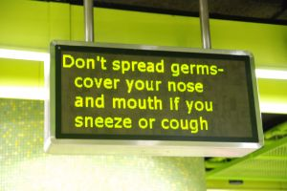
Identifying workplace food safety hazards and risks is a critical element in applying safe food handling practices as identification of the problem is necessary to allow problems to be addressed.
This section describes methods of identification, defines hazards and risk, explains generic hazards and risks relating to food hygiene and food safety and identifies practices associated with individual work roles.

How to identify these hazards and risks
The standard ways to identify key food safety hazards and risks in the workplace are:
- Personal observation – of:
- Workplace practice
- Foodstuff
- Tools and Equipment – these may be varied but can include but not limited to temperature thermometers and readers, warning or indication signs
- Compliance with safe food handling practices and established, internal requirements
- As a result of personal experience with items and situations – you will gain increasing knowledge as you work with food which will help you identify issues and analyse situations
- Analysis of food safety records, documents and logs – which can reveal issues such as:
- Tools & equipment and areas requiring attention or repair
- Refrigeration and freezers operating at incorrect temperatures
- Food holding and display equipment operating at incorrect temperatures
- Equipment and areas requiring attention or repair
- Staff who are ill and who should be excluded from food handling duties
- Conducting regular and scheduled workplace inspections and checks (audits) – to identify problem situations.

Hazards and risk
Hazards and risks can occur at any stage in the food handling process.
A hazard may be seen as something which actually exists and is likely to cause/result in harm.
A risk may be seen as:
- Something likely to occur which would cause harm
- The potential for harm/injury to occur when a hazard occurs.
For practical purposes the two terms can be used interchangeably.
Types of contamination
There are three classifications of contamination present the potential for food hazards:

- Microbiological contamination
- Chemical contamination
- Physical contamination.

Microbiological contamination
Microbiological contamination is caused by bacteria, moulds, yeasts and viruses via intoxication or infection.
Problem bacteria include:
- Clostridium perfringens – usually caused when food is cooked, chilled overnight and re-heated, or found in foods that are cooked 'rare'.
The initial source of the contamination is faeces (man, birds, animal or insects) which is introduced somewhere along the food chain/production line (failure of staff to wash their hands after the toilet; flies carrying it onto food; contamination at the abattoir)
- Salmonella – a very common contaminant. Faecal contamination is a prime source (failure to wash hands after the toilet; flies carrying it onto foods; leaky plumbing; fish harvested from waters polluted by sewage)
- Streptococci – caused by nasal or oral discharges into food (coughing, sneezing), either directly or via hands that have been so contaminated
- Staphylococcus aureus – rapidly-acting bacteria where the main source is the food handler: nose, throat, mouth, skin, pimples and cuts.
Contamination may occur directly (coughing or sneezing onto food) or indirectly (coughing/sneezing into hands and then using the hands to handle food)
- Clostridium botulinum – a rare bacteria but a very lethal contaminant (65% mortality rate).
Can occur when heat processing of tins and jars is incomplete allowing spores (see below) to survive and cause the problem.
Any tin that 'spurts' when opened, is leaky or is 'blown', or jars with broken seals must be discarded as this is a sign of botulism contamination: there is no adverse smell and food must not be tasted to test it as the small amount ingested during tasting can kill.
Note there is usually no sign food has been infected by bacteria.
High risk food handling situations
High risk food handling situations that may involve microbiological contamination include:
- Working with any high risk/potentially hazardous foods
- Working in temperatures that promote rapid bacterial growth
- Displays of food and buffets – where the temperature may be compromised (hot food may fall below 60°C, cold food may rise above 5°C), plus there is always the danger members of the public – untrained in correct food handling procedures – may contaminate the food
- Processing the food where it is touched by the bare hand and not subsequently cooked
- Any situation requiring thawing and re-heating of high risk food always poses a risk the food may stay in the Temperature Danger Zone too long.

Chemical contamination
Chemical contamination can include contamination caused by chemicals:
- Used on the food to produce and/or process it
- Over usage of fertilizers and pesticides by farmers
- Contaminated food by radioactive particles
- Which find their way inadvertently into the food due to careless handling – for example:
- Fly spray sprayed into the air and landing on food
- Using a jug/container to measure chemicals and then using the same jug (without washing and sanitising) to mix a sauce which is poured over food.
Specific and identified measuring vessels should always be allocated for chemicals – staff must not be allowed to use food service items to obtain, measure or pour any chemical.
All chemicals must be stored away from food areas at all times.
Naturally occurring poisonous food
Naturally occurring poisonous food are also classified as part of the ‘chemical contamination’ threat.
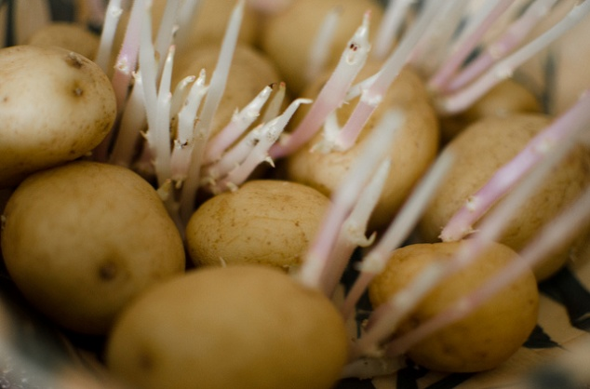
Be aware of the following:
- Mushrooms – certain fungi can be poisonous but those purchased from reputable suppliers should be safe: do not buy mushrooms from people calling door-to-door, and do not use in a commercial setting, mushrooms picked by private individuals
- Rhubarb leaves are poisonous so great care should be given when stemming them
- Green and sprouting potatoes including tuber group contain a substance called 'solanine' which has been linked with food poisoning outbreaks so green potatoes should be discarded, returned to the supplier or rejected on delivery.
- Over eating of Dgenko fruit can cause poison in most of the south east Asia countries.
- Unmatched food such as mangosteen fruit and sugar can cause poison

Physical contamination
All food handlers must be on their guard to ensure foreign objects do not find their way into food for human consumption.
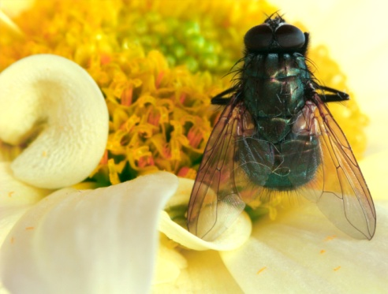
Remember, too, the foreign object may have found its way into the food before the product arrived at the premises.
Be on the lookout for contaminants such as:
- Hair from the head or beard
- Metal filings left by can openers
- Flies and insects – and their droppings
- Bits of equipment and utensils which break off during the food preparation process and become incorporated into the food
- Bits of glass.
- Fishing hooks, button, jewellery and small nail
These are only a small sample - the list is endless!

Personal responsibility
You have direct responsibility for the work you are being asked to perform and the area in which this work is done.
For example:
- A dishwasher will have responsibility for cleaning the crockery and cutlery and will not be expected to monitor food safety in relation to food preparation, cooking or service
- Someone serving food to the public will have responsibility for the safety of the food they are serving and the items (crockery, cutlery, take-away containers) they are serving into and onto – they will not have responsibility for checking deliveries which are coming into the venue, for verifying food is being cooked properly or for washing the plates
- A person cooking the food will focus on ensuring the required cooking times and temperatures for dishes are being achieved and the food is being protected from contamination during the cooking process – they will not worry about displaying the food correctly or serving it safely.
Examples of other responsibilities relate to activities such as:
- Purchasing and receiving goods delivered into the premises by suppliers
- Dry, cold and frozen storage of food which has been delivered
- Thawing of frozen food and preparation activities (washing, peeling, chopping, mixing, weighing) food
- Cooking food ready for immediate consumption and cooling food which has been cooked so it can be refrigerated or frozen for later use
- Cold holding and hot holding of prepared food so it can be kept ready for sale or service
- Re-heating of prepared food where previously prepared food (or left-over food) is safely heated up for service
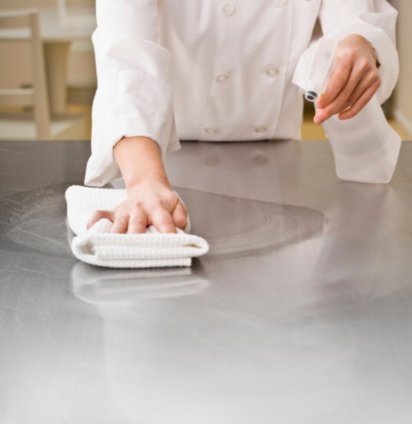
- Displaying hot and cold food for service to customers
- Supervising the self-service of food by customers to themselves
- Serving food which may packaging food for take-away consumption or plating food for eat-in consumption
- Cleaning food equipment, utensils, work areas and food contact surfaces.
Additional food safety responsibilities
You will also be expected to:
- Participate in venue-wide food safety
- Assist other staff in their designated work roles to identify hazards and address issues
- Seek advice and direction from a more experienced and senior person when unsure about what to do in terms of maintaining a safe food handling environment.

1.2 Check own work area to identify hazards and risks

Introduction
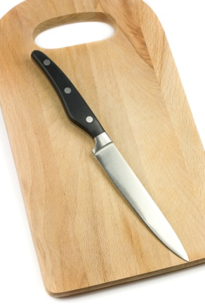
Every food handler has a responsibility to their employer and to the public to ensure food safety for the area in which they work and the food they handle.
This section describes possible checking processes in the workplace, presents more examples of hazards and identifies basic responses to out of control situations.

Checking processes
Checking your work area to identify hazards and risks may involve:
- Inspecting the work area prior to commencing work:
- Food areas, tools, equipment and utensils are clean
- No evidence of pests/vermin infestation
- Temperatures of refrigerators, cool rooms and freezers are correct
- Deliveries have been inspected before storage and stored appropriately and promptly
- Following the requirements of any workplace-specific checklists which may be provided to guide inspections and checking
- Monitoring work on an ongoing basis – to ensure:
- Required SOPs and work practices and protocols are being implemented
- Food safety is being maintained
- Tools and equipment is operating correctly
- Required temperatures (for processing and holding and display) are being maintained
- Required cooking times for food is being achieved
- Cleaning and sanitising of food equipment, not including deep fryer, bain-marie, large stock pots, boiling jacket pan, is occurring in between uses
- Cleaning of food areas and food contact surfaces is occurring at least every four hours. However chopping boards must be cleaned after being used.
- Spills are cleaned up promptly as they occur
- Rubbish is being removed regularly
- Personal hygiene requirements are being consistently implemented – see section 2.1

- Verifying safety of food to be used:
- Inspecting for signs/evidence of contamination
- Checking use-by date / expiry date / best before or shelve life
- Ullage: (evaporation/leakage in tin provisions),corroding changing colours, bulging
- Ensuring packaging has not been compromised
- Observing food handling practices of colleagues – to ensure they also handle food safely and hygienically
- Testing equipment – to make sure it is operating correctly.

More examples of hazards
Food handlers must also be alert to the following hygiene hazards and take appropriate action, where necessary.
Examples include:
- Food contaminated by vermin – through urine, faeces, gnawing, their presence in it
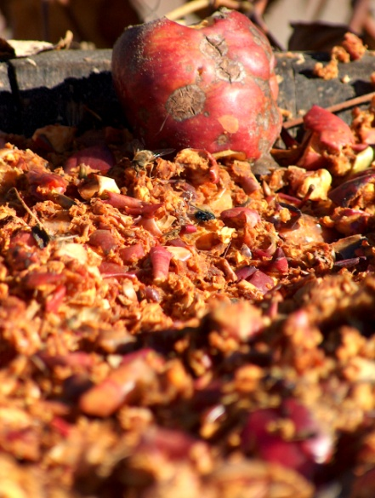
- Airborne dust – either due to natural causes (dust storms, weather) or due to internal causes (renovations)
- Contaminated items – such as linen, tea towels contaminated with human waste such as blood, secretions (sweat) or food
- Dirty equipment and utensils – which can include:
- Items not properly cleaned and sanitised after use
- Items dropped on the floor
- Items contaminated by clothing, coughing, sneezing, or cross contamination (see section 2.3) of any sort
- Garbage – all garbage presents a potential hazard whether it is stored in bins inside the premises or in containers outside the premises: remember hands must be washed after handing garbage and all garbage containers must be covered with a lid and kept clean when not in use
- Out-of-date food handling practices ((Out-of-date food must be thrown away and cancelled) – hazards can occur where:
- The nature of the food operations being undertaken have changed
- The food equipment being used has altered
- The food items being processed have changed
and there is no subsequent and appropriate alteration to the previously existing food handling protocols
- Colleagues who require training – Food handling staff who never attend the food safety course or even where staff have undertaken an approved food safety course there is no guarantee they will apply, in the workplace, the lessons they have learned: where workers are using incorrect food service practices and/or failing to observe other safe food handling principles (especially in relation to personal hygiene, hand washing) there is a need for re-training
- Equipment not operating as intended – this typically includes all food processing and holding equipment (especially refrigerators/cool rooms, freezers, food warmers and bain maries) as well as food thermometers.

Taking appropriate action
Appropriate action will depend on the hazard identified and examples of detailed responses are provided in section 4.3.
Keys in responding to these threats are:
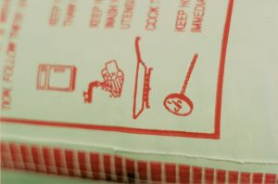
- Awareness – of what causes problems and poses hazards and risk
- Training – how to safely handle and store food, how to identify hazards and correct steps to minimise or eliminate hazards
- Constant vigilance – of what is happening (or not happening) in the workplace
- Due diligence – ensuring all safety measures, including safe food handling policies and procedures are adhered to
- Quick and effective responses – where you are able to act effectively in accordance with the scope of authority for your job
- Recording in log book
- Immediate reporting – to (for example) supervisor, chef, manager or owner where you identify non-compliance with safe food handling requirements and any out-of-control situations.
Work Projects
It is a requirement of this Unit you complete Work Projects as advised by your Trainer. You must submit documentation, suitable evidence or other relevant proof of completion of the project to your Trainer by the agreed date.
  - Identify one food handling role or position in a food premises and prepare a written submission which:
- Identifies the main food hazards and risks associated with that position or role
- Lists practical workplace actions which can be taken to check the work area to identify food hazards and risks
- Provides an overview of how identified hazards and risks may be effectively addressed.

Summary

Identify hazards and risks
When identifying hazards and risks:
Use personal observation
Gain experience to help provide a basis for analysing what is occurring
Read workplace food safety records to determine what is happening
Undertake regular and required workplace inspections and checks
Be alert to the potential for microbiological, chemical and physical contamination
Pay special attention to high risk food handling situations
Focus on the food handling area and activities for which you have direct responsibility
Be prepared to assist in venue-wide safe food handling initiatives and requirements
Ask for help, advice and direction when not sure about what to do
Apply checking procedures to verify safe food handling protocols are being applied
Protect food from contamination
Take appropriate remedial action where necessary
Report instances of non-compliance and out-of-control situations.

Element 2:
Follow enterprise hygiene standards, procedures and practices

2.1 Implement required personal hygiene practices

Introduction
Food handlers must be aware they themselves, their actions, their health, and their personal habits have a great impact on the safety and quality of food served to the public.
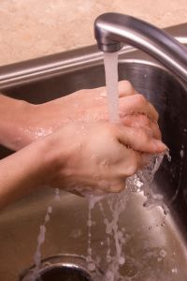
This section identifies and describes the personal hygiene practices food handlers must implement.

The importance of personal hygiene
Personal hygiene is a serious issue and must be treated as such: the industry simply cannot afford to tolerate workers who treat it as a joke.
Food handlers are regarded by patrons and employers as professionals and must therefore know what is expected, cultivate sound work practices, and be vigilant in ensuring personal hygiene requirements are complied with.

Personal hygiene practices
In general terms all food handlers are under an obligation to observe and implement personal hygiene practices which minimise the possibility of food contamination.
Practices to achieve this include:
- Have a shower before work
- Wash hands using the standard procedure
- Avoid touching cooked or ready-to-eat food with the bare hands – use tongs, a spatula, fork, serving spoon or gloves
- Avoid touching food surfaces with the bare hands – this means avoiding touching preparation benches, preparation equipment and the food contact surfaces of serving items (plates, cutlery, glasses, cups)
- No jewellery to be worn on hands and wrists – food can lodge in the jewellery, deteriorate and then fall back into food.
- No wearing of wrist watch on duty – for the above reasons. There is also a chance stones or gems may fall out into the food providing a physical food contaminant. If you must wear a ring then cover it using a coloured band-aid and glove
- Facial hair must be kept neat and controlled – hair should be covered to keep it controlled in such a way that hairs do not fall into food. Long hair must be tied back (this is applicable to waiting staff as well as food preparation and food service staff), and beards should be covered with a snood. In kitchens, hair nets or hats should be worn
Fingernails must be short, clean and free of polish (including clear nail polish) – cracked fingernails and chipped nail polish can harbour bacteria and may also flake off into food. Fingernail decorations and artificial nails are also prohibited
Clothing must be clean – a minimum requirement is for clean clothes for each shift with further changes as spillages and 'working dirt' dictate. It is not permitted to wear ‘food handling’ clothes to and from work
- Refrain from smoking or chewing tobacco or betel in any food area – it is also a good idea to put up ‘No Smoking’ posters and to remove ash trays from these areas
- Staying away from work when suffering cold or flu symptoms – and obtaining a doctor’s certificate stating that as a food handler it is safe to return to work
- Food handlers with any communicable disease must not deal with food until they receive a certificate from a doctor stating as a food handler they are cleared to work with food
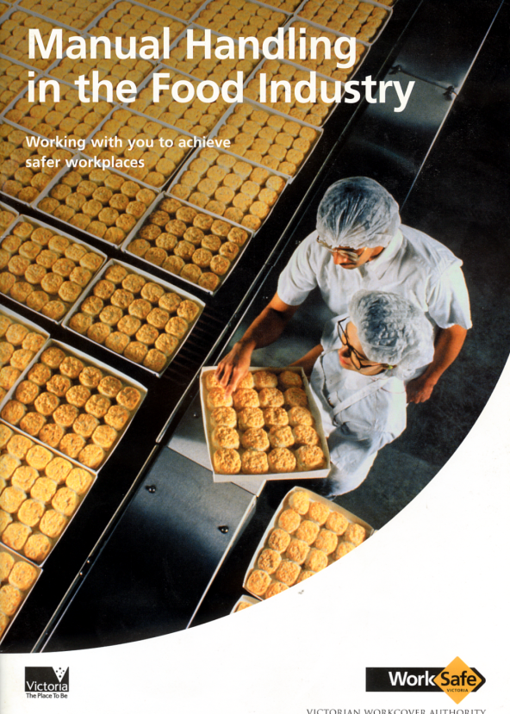
- Refrain from spitting in any food area
- Avoiding tasting of food with a spoon and then returning the utensil to the food
- Consider wearing a sweat band – or mopping areas that sweat and then thoroughly washing hands: consider wearing anti-perspirant
- Covering all cuts and sores on hands and fingers with approved (coloured) waterproof dressings and bandages – and adding a finger stall and or disposable glove, as appropriate
- Not blowing with the breath into a bag to be used to wrap food
- Not wetting fingers to assist with separating sheets of wrapping paper when packaging take away foods
- Not touching anybody opening – such as ears, eyes, nose: thorough hand washing must occur if this happens
- Hands must be washed properly – and washed when required (see below).
Eating in food areas
There is no law forbidding staff from eating in food preparation areas but they must:
- Not eat any food over an unprotected food surface – such as food preparation equipment, preparation benches, serving equipment or crockery, cutlery or glassware
- Not eat any food over any unprotected food – this applies to raw food, ready-to-eat food or any food that is not covered, wrapped or packaged so that it cannot become contaminated through food falling onto it.
Note individual premises may have house policies forbidding the consumption of food while working.
Note also the above requirements in relation to eating over unprotected food and unprotected food surfaces applies to anyone on the premises – including members of the public, customers and visitors.
Action to take
Where it is known or suspected a food surface has been contaminated by coughing, sneezing or any other unsafe practice (such as anything giving rise to cross contamination) the surface must be cleaned and sanitised before being re-used.
Where it is known or suspected unprotected food has been contaminated by coughing, sneezing or any other unsafe practice (such as anything giving rise to cross contamination) it must be discarded.
Any food that is known to be contaminated, or suspected of being contaminated, must be disposed of as garbage – it must not be given away to customers, staff or any organisation.

Hand washing
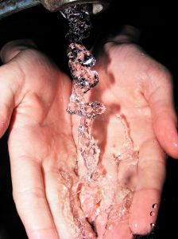
Health authorities believe the single most important aspect in preventing food poisoning outbreaks is for food handlers to wash their hands properly and to wash them ‘when required’.
When must food handlers wash their hands?
All food handlers are required to wash their hands before or after nominated activities.
The intention of this is to ensure the hand washing process removes potential food poisoning sources from the hands so the possibility of cross contamination is reduced.
The times when food handlers must wash their hands are:
- Any time the hands are likely to be a source of contamination – this can cover a wide range of possible circumstances and it is impossible to identify them all but the following is a representative list:
- After handling rubbish or garbage and before handling food or food contact surfaces
- After undertaking cleaning duties and before handling food or food contact surfaces
- After handling animals and before handling food or food contact surfaces
- After accepting a delivery of food into the premises and before handling food or food contact surfaces
- After handling money and before handling food or food contact surfaces
- In between handling raw high risk food (meat, fish or chicken) and handling cooked or ready-to-eat food
- Before they start their food handling duties – this means food handling staff must wash their hands when they arrive at work even though they may have showered, bathed or washed their hands at home before coming to work
- Immediately after engaging in nominated activities which have proved to be associated with bacterial transfer/cross contamination.
The nominated activities include:
- Smoking – including using tobacco products
- Coughing or sneezing
- Using a handkerchief or nasal tissue – which includes blowing the nose
- Eating or drinking
- Touching hair, scalp, mouth, nose, ears, anybody opening or any wound
- After any absence from the work station – this means every time a food handler leaves the kitchen (or other place where they are handling food) they must wash their hands on their return to work and before they handle food.
These absences from the work station may involve or be caused by:
- Leaving the kitchen to accept a delivery of food
- Taking a phone call
- Undertaking any work which is not related to food handling
- Immediately after using the toilet and before handling food or food contact surfaces – this applies to all instances where the toilet was used and includes a requirement to wash hands after urination as well as after defecation.

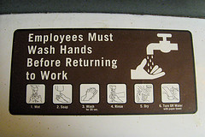
Provision of hand washing facilities
To allow food handlers to wash their hands as required, employers are obliged to provide and maintain permanent and readily accessible hand washing facilities.
These hand washing facilities must:
- Be supplied with a continuous supply of warm running, potable water – the accepted temperature of this water is 40ºC
- Be supplied with soap – most premises use bulk soap dispensers dispensing liquid anti-bacterial soap.
The use of bars of soap is to be avoided as the soap can transfer bacteria
- Only be used for washing hands, arms and face – the wash hand basins must not be used for other purposes such as food preparation or as a ‘slop’ sink.
Signage must indicate these wash hand basins are for the sole purpose of hand washing.
Sinks in the kitchen or food preparation area used for other purposes (washing food; cleaning pots and pans) must not be used for hand washing
- Be of an appropriate size to enable the effective washing of hands
- Be supplied with appropriate means of drying the hands – this can be single use (paper) towels and hot air dryers.
It is not acceptable for a business to provide only a hot air dryer.
Re-usable towels can be used provided they are washed and dried after every use – this is extremely unlikely to happen in most businesses so the preferred option is to use paper disposable towel
- Be supplied with a bin – for disposing of used disposable towels.
A nail brush should also be supplied so cleaning under the fingernails can occur.

How to wash hands
Many food handlers believe hand washing is such a basic human task they do not need to be told how to do it but it is almost always the case ‘experienced’ food handlers have no real idea of what comprises effective hand washing.
The following points must be implemented when food handlers wash their hands.
The requirements are food handlers ‘thoroughly clean’ their hands, meaning they must:
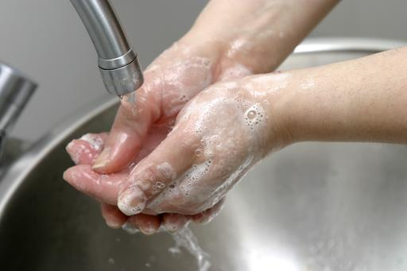
- Rinse off visible and easy to remove dirt
- Apply soap
- Wash hands for at least 20 seconds:
- Thoroughly and vigorously massage the soap into the folds and creases of the hands and wrists
- Clean under the fingernails
- Rinse soap from hands
- Thoroughly dry hands – the preferred method of drying hands is to:
- Shake off excess water
- Dry with paper towel
- Finish with hot air dryer.

Organisational requirements
All food handling premises are entitled to implement policies and procedures which exceed minimum legal requirements.
This means, for example, a food handling premises may require food handlers to wash their hands every 30 minutes (or every hour) regardless of what activities they are engaged in.
A business may also require staff to wash their hands in the wash hand basin in the toilet after using the toilet, and then wash their hands again when they re-enter the kitchen area.
Where the workplace has hand washing requirements exceeding the mandatory minimum requirements, always adhere to these workplace practices.

2.2 Maintain clothing to meet work area standards

Introduction
Food handling staff must ensure their clothing meets workplace standards and does not contaminate food or food surfaces.
This section contains a range of requirements relating to the proper maintenance of food handling uniforms/clothing.

Use of suitable dress and PPE
Food establishments may require staff to wear a nominated uniform or other personal protective equipment or clothing.
The following requirements apply:
- Uniform and protective clothing and equipment worn/used by food handlers must be clean – dirty clothing may directly or indirectly contaminate food and or food preparation equipment or surfaces
- Food handlers are legally obliged to ensure their clothing does not contaminate food or food-related equipment, utensils or surfaces
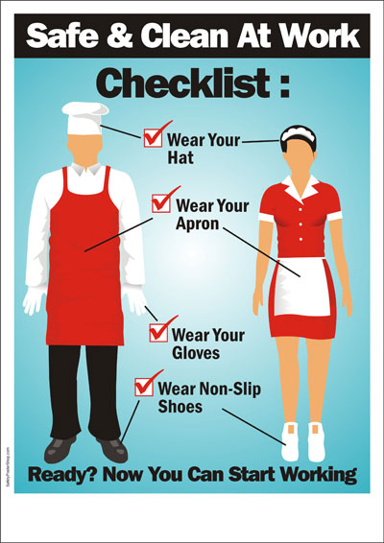
- Clothing that becomes dirty and a risk to food must be changed – you should take into account the nature of the work being performed when making a judgement about the state of your clothes.
For example, a cook dealing with raw meat and blood can be expected to have dirtier clothes than a counter-hand making sandwiches or serving prepared food
- Outer clothing needs to be changed when it has become soiled as a result of handling exposed (that is, not packaged) high risk raw food and there is then a need to handle exposed ready-to-eat food
- Protective clothing such as aprons, overalls, hats, gloves and other outer protective clothing and equipment should be removed before visiting the toilet.

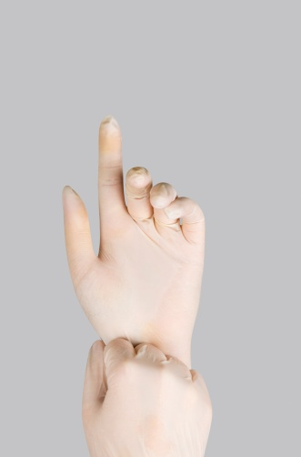
Other requirements
Requirements may include:
- Avoid loose-fitting clothes – they increase chance of clothing dragging into food and posing a contamination threat
- Wear clean clothes to work daily
- Have a change of clothes available at work
- Do not wear food handling clothes to and from work
- Wear protective clothing such as aprons
- Ensure buttons on food handling clothes are not loose – or they may fall off and drop into food presenting a physical hazard
- Avoid adding brooches, name tags, clips, pins to clothes – unless they are securely fastened and unable to fall off.
Jewellery
Practical food safety measures in this regard include:
- Avoid rings and watches on hands and wrists.
Even plain, banded rings can cause a potential food poisoning source and gloves should be when handling food if these are worn
- Do not wear ear-rings – ear-rings that dangle are the worst but not wearing them at all is preferable.
Sleepers may be acceptable in some venues but check house rules first
- Avoid fiddling with jewellery – especially ear-rings in pierced ears.
Hair Accessories
Practical measures in this regard include:
- Avoiding wearing hair clips
- Avoiding using hair pins
- Ensuring anything worn in the hair is securely fastened in place
- Wearing a hair net or hat to guard against items falling out of the hair and into food or into food preparation equipment or onto food preparation surfaces.

2.3 Follow hygiene procedures in accordance with enterprise requirements

Introduction
It is essential all food hygiene protocols are implemented in accordance with enterprise requirements.
This section identifies relevant food safety practices which need to be adhered to.

Cross contamination
All food handlers must be aware of the concept of cross contamination.
Cross contamination is the contamination of food (or food preparation surfaces, equipment etc.) with bacteria, chemicals or allergens as a result of contact with a contaminated source.
Bacteria cannot fly, jump or hop so they depend on people to move them around from place to place via direct contact or through indirect contact.
Direct contact
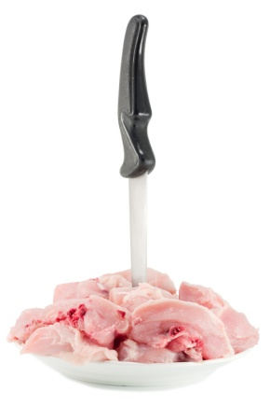
Examples of direct contact are:
- Using a knife to cut raw meat and then using the same knife to cut cooked, ready-to-eat meat without cleaning and sanitising the knife in between tasks – the blood and residual meat on the knife will carry bacteria and this will be transferred by the knife to the previously safe cooked, ready-to-eat meat
- Using a chopping board to cut raw chicken and then using the same chopping board to cut cooked meat for salads without cleaning and sanitising the board in between tasks – the chopping board will carry bacteria from the uncooked chicken (the cooking process should destroy the bacteria) which will then be transferred to the previously safe to eat cooked meat.
Indirect contact
As previously explained this involved coughing or sneezing into a hand and then using that hand to prepare/touch food or to touch a food preparation surface.

Preventing cross contamination
Key Points
In this section a number of very important points relating to ways in which to prevent cross contamination will be mentioned.
Before we explore these different strategies it is important to note some key points that staff should follow in daily practices:
- Clean and disinfect food preparation areas and equipment
- Careful avoidance of meat contaminated with salmonella and pathogens
- Extreme care in preparing raw food
- Institutional dish sanitizing with soap and clean water
- Washing of hands thoroughly before touching food
- Avoid using the same utensils for other food
- Avoid using utensils that have been licked.
- Observe proper storage of food
- Practice appropriate refrigeration of food
- Label food to indicate the life span of food
- Proper disposal of uneaten food and packed or canned food stuff.
Further actions to assist in preventing cross contamination include developing and implementing SOPs to eliminate the possibility of cross contamination including:
- Using separate staff to handle raw high risk food and other food that is cooked or ready-to-eat
- Washing and sanitising all preparation surfaces, equipment and utensils in between each use
- Using colour-coded chopping boards – see below for details
- Ensuring proper personal hygiene practices are implemented
- Keeping chemicals away from food and food preparation/service areas – this includes eliminating the use of chemicals in food areas when food is present
- Using cleaned and sanitised containers for every food preparation and storage requirement – this applies to all storage, preparation or display environments
- Using only cleaned and sanitised crockery, cutlery and glassware for the service of food and drinks – this includes ensuring all service items are properly stored after cleaning to protect them from contamination
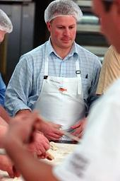
- Using only disposable (paper) towels for wiping hands or cleaning up spills and immediately discard after use – do not use clothing (such as fronts of jackets, aprons) or cloth tea towels
- Never storing raw high risk food above cooked and/or ready-to-eat food – to eliminate the risk posed by blood/juice dripping onto raw food below
- Never storing food containers on the floor
- Using hand wash sinks only for hand washing – and not using food preparation sinks for hand washing
- Cleaning and sanitising probe thermometers in between each use
- Cleaning low risk areas and equipment before cleaning high risk areas when the same cleaning items or equipment have to be used
- Washing all fruit and vegetables, especially salad vegetables, in a sanitising solution before use
- Wearing clean clothes and clean protective clothing for each shift
- Cleaning and sanitising food equipment, utensils and preparation areas in accordance with the cleaning schedule for the premises – including the cleaning and sanitising of preparation benches in between preparing raw high risk food and other foods (see section 3.2)
- Using waterproof bandages on cuts and sores – and coloured band aids
- Washing – and properly drying – hands when and as required
- Separating the storage of raw and cooked/ready-to-eat foods – by storing (for example) in different areas of the refrigerator and on separate trays
- Keeping foods covered as much as possible when in storage, while being processed and displayed
- Using separate sinks for washing ready-to-eat salad vegetables/vegetables and other high risk foods – this includes a requirement a sink used for thawing high risk foods by running it under cold water should take place in a different sink to the one used for washing salad vegetables/vegetables
- Changing disposable gloves whenever there would be a need to wash hands – such as in between handling raw high risk food and cooked/ready-to-eat food: gloves should be changed every hour regardless
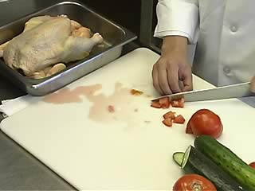
- Not mixing batches of food
- Refraining from tasting food and replacing the spoon back in the pot
- Not coughing or sneezing over food or food preparation equipment, utensils or surfaces
- Cleaning and sanitising knives in between cutting raw high risk foods and cooked/ready-to-eat foods
- Cleaning and sanitising food preparation benches and equipment that are in constant use at least every four hours
- Avoiding the use of the same cleaning equipment between other areas of the premises (such as bathrooms and bedrooms) and the kitchen
- Repairing cracked surfaces in the food preparation area
- Excluding pests and implementing an effective pest control program – which may necessitate the use of a qualified professional external pest control company
- Discarding all food that is known to be contaminated – or suspected of being contaminated
- Excluding food handlers who are ill from food handling and food-related activities
- Displaying food so it is protected from contamination by customers – including the use of sneeze guards, monitoring patron actions where self-service food is available and taking appropriate action when the potential for cross contamination to have taken place has been identified
- Disposing of any food dropped on the floor
- Disposing of any food returned from a patron – this includes food and beverage items
- Disposing of any single-use item which has been used once and/or has become contaminated (or is suspected of being contaminated) for any reason
- Putting up signs/posters in the workplace to remind food handlers about cross contamination
- Inspecting food deliveries into the premises to ensure they are not contaminated by any visible sources.
Most of the following points relate to cross contamination and how to prevent it and additional information is presented in section 3.1.
Using colour-coded chopping boards
Using colour-coded chopping boards will reduce the likelihood of cross contamination.

The following explains the uses of these boards highlighting how different coloured boards will help keep different foods separate and hence reduce the potential for cross contamination:
- White – for dairy products only
- Red – for raw meat only
- Blue – for seafood only
- Yellow – for poultry only
- Brown – for cooked meat only
- Green – for fruit and vegetables only.
After use all boards should be scraped with a flat metal scraper and washed.
Note Polyboards can be put through the dishwasher and sanitised.
Wooden boards are not the preferred option but if they are used, they should be washed with hot soapy water and sanitised: salt may be added to the surface to draw out moisture when not in use and cleaned away prior to use.

Preventing unnecessary direct contact with ready-to-eat food
Unnecessary contact with ready-to-eat food raises the likelihood of contamination occurring.
This is because the food will be consumed without any further processes (such as cooking, re-heating) being applied to it that may kill food poisoning bacteria.
Methods to prevent direct contact with ready-to-eat foods
Practical measures in this regard include:
- Wearing disposable gloves – and changing them as required (see below)
- Using utensils (tongs, spatulas, forks, spoons) instead of bare hands to handle ready-to-eat food
- Using paper (tissue/packaging materials for take-away food) to act as a barrier between ready-to-eat foods and bare hands.
Using disposable gloves
The use of protective, disposable gloves in food handling is an excellent safe food handling practice but gloves cannot fix all food hygiene problems.
Requirements relating to the use and wearing of disposable gloves include:
- Change gloves immediately they are ripped or torn
- Change gloves between handling raw high-risk food and cooked, ready-to-eat foods
- Change gloves every hour regardless
- If handling money do not use gloved hand to handle food
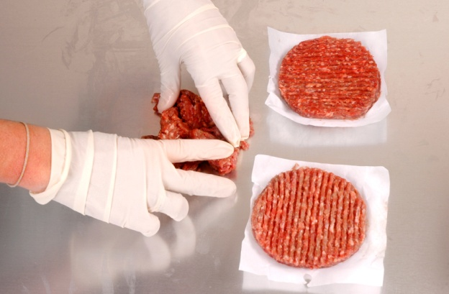
- If changing gloves during service ensure they are not taken off over food or food surfaces if the gloves contain powder as the powder may provide a source of contamination
- Do not try to put on gloves that have already been used
- Do not turn gloves inside out and try to wear them again
- Change gloves whenever they become contaminated from whatever source – raw food, blood, sneezing, chemicals, scratching the face, handling rubbish
- Whenever required to wash hands, gloves should be changed.

The use of single-use items
A single-use item is something intended to be used once only in relation to food and then disposed of.
Single-use items must not be re-used even if they are cleaned in between uses.
Examples of single-use items include:
- Take-away food and drink containers
- Drinking straws
- Disposable gloves
- Plastic cutlery
- Food wrappers – around items such as hamburgers and other take-away menu items.
What requirements apply to single-use items?
Single-use items:
- Must not be used more than once by the business – customers are free to re-use them at home as they see fit.
Note single-use containers may, however, be used for non-food activities – such as collecting or storing dirty cutlery
- Must be stored and or displayed so as to be protected from contamination – this contamination may be from:
- Flies, pests and vermin
- An infected food handler
- Airborne contamination
- Physical contamination
- Customers
- Must not be used if it has been contaminated – or there is a suspicion it may have been contaminated. This may mean:
- Disposing of any single-use items handled by customers
- Disposing of any single-use items which have been dropped on the floor
- Disposing of any single-use items where the protective packaging they were delivered in has been compromised
- Must be clean in order for it to be safely used – meaning free from visible contamination of any sort (including food).
Practical measures
Practical measures in relation to single-use items include:
- Not preparing take-away containers (for example, pizza boxes) in advance and leaving them ‘open’ – this allows airborne and other contamination to settle inside the boxes on the food contact area: pizza boxes should be constructed ‘to order’
- Providing drinking straws in containers to allow one straw at a time to be dispensed without others in the container being touched: an alternative is to only use individually wrapped drinking straws
- Storing take-away food containers (for food and beverages) upside down – so the food contact surface of the container is not exposed
- Storing the lids to take away containers safely – so that the side that makes contact with the drink/food is protected
- Disposable cutlery should be kept covered or individually wrapped
- Toothpicks should be individually wrapped
- Disposing of any portion control units which have been damaged or already handled by customers.
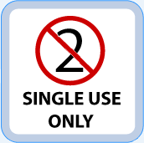
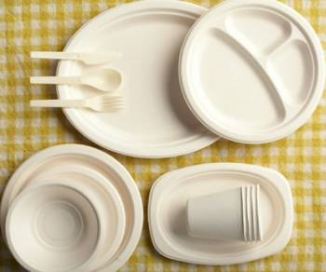
Work Projects
It is a requirement of this Unit you complete Work Projects as advised by your Trainer. You must submit documentation, suitable evidence or other relevant proof of completion of the project to your Trainer by the agreed date.
2.1 Prepare two posters suitable for use in a workplace instructing/advising new food handling staff about:
- Personal hygiene requirements and the obligations they are under/need to comply with
- Clothing requirements for food handlers.
2.2. Interview an owner, operator or manager of a food business and ask them about the hygiene procedures and enterprise requirements they have in place to ensure the safety of food they serve.
Submit a written report presenting the answers they provide.

Summary

Follow enterprise hygiene standards, procedures and practices
When following enterprise hygiene standards, procedures and practices:
Implement all necessary personal hygiene practices
Wash hands properly and when required
Use and wear PPE as required
Avoid/prevent cross contamination
Consider using colour-coded chopping boards
Prevent unnecessary direct contact with ready-to-eat food
Use disposable gloves
Do not re-use single serve items.

Element 3:
Handle and store foodstuffs

3.1 Handle and store foodstuffs according to enterprise guidelines

Introduction
Al food must be handled and stored correctly.
This section describes optimal storage options and conditions. It also identifies safe food handling techniques.

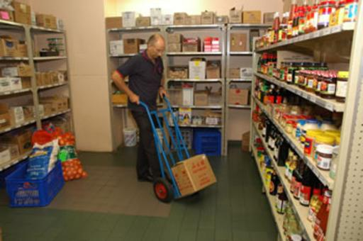
Food storage
There are three basic storage methods:
- Dry goods storage
- Refrigerated goods storage
- Frozen goods storage.
Detailed information on requirements for each store are presented in the next section.
Standard safe food handling requirements in relation to food storage are:
- Use food grade materials to store food susceptible to contamination – such as stainless steel
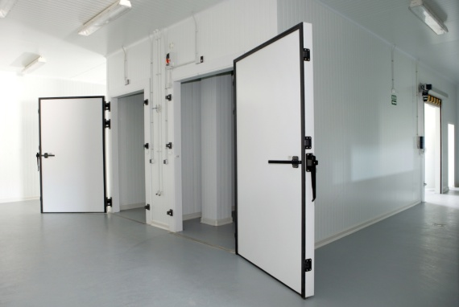
- Cover food that is in storage to protect it from contamination
- Rotate stock to ensure it is used in the correct sequence – the method used for most food is called ‘First In, First Out’ (see section 3.2). Any food exceeding its use-by date must be thrown out
- Keep all storage areas and equipment clean
- Never store food, including packaged food, directly on the floor. Use shelves or stack on pallets
- Ensure pests and rodents are excluded from food storage areas – conduct a regular check of all storage areas. Undertaking weekly inspections are recommended with staff taking appropriate action where evidence of pests or rodents is discovered. Each organisation will have their own policies and procedures in relation to this matter.

Safe and hygienic food handling
By definition beverages are included as food so all requirements applying to edible food apply equally to beverages/drinks.
Safe food handling techniques are techniques used to control the safety of food and they cover processes from the receipt of food into the premises to the disposal of waste produced by food processing activities.

Food receipt
Safe food handling requirements in relation to food receipt are:
- Inspect the deliveries – the FSP may require a visual inspection of a set number of deliveries (such as 5%) to make sure:
- The food is free from visible contamination – for example:
- Frozen food is hard frozen
- Packaging and wrapping is not torn
- The integrity of tins, bottles and other containers has not been compromised
- There are no leaking food containers
- The delivery does not bring in pests or rodents
- The use-by dates of the food are acceptable – reject any food delivered beyond its use-by date or where it is believed it will not be able to be used before it reaches its use-by date
- Inspect the food delivery vehicle – check it is clean and is a dedicated food delivery vehicle
- Check the practices of the delivery driver – check things such as:
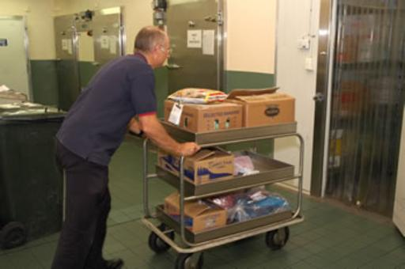
- Whether or not food is protected during the delivery process – is the delivery vehicle left unlocked during deliveries? Is food placed on the footpath? Are there chemicals mixed in with the food items?
- Personal hygiene of the delivery driver
- Ensure someone is at the premises to receive the food – deliveries should not be left at the premises unattended as this raises the possibility of contamination (from birds, dogs, cats) as well as potential for theft
- Check the temperature of the food in accordance with the requirements of the FSP using a properly calibrated thermometer (see section 3.3):
- Frozen food should be hard frozen with no evidence of defrosting: -15ºC is the recommended temperature
- Hot food that is ‘potentially hazardous’ must be at 60ºC or above

- Potentially hazardous refrigerated food must be at 5ºC or below.
Potentially hazardous food may be accepted where the delivery driver can demonstrate (that is, prove to your satisfaction) the combination of time and temperature have not adversely impacted on food safety. In general terms, if the food has been in the Temperature Danger Zone for 2 hours or longer the food should be rejected
- When accepting a delivery of potentially hazardous food that is in the Temperature Danger Zone, it should be used first/immediately and not be subject to the standard stock rotation principle of First In, First Out
- Check all packaged food is properly labelled with the name of the supplier, manufacturer or vendor – all food delivered into a food premises must be able to be identified so as to assist with food recalls and to help identify the source of problems/contamination where an outbreak of food poisoning occurs
- Store all deliveries as soon as possible after they have been delivered and checked – never leave refrigerated or frozen food lying around in the receival area.


Potentially hazardous food
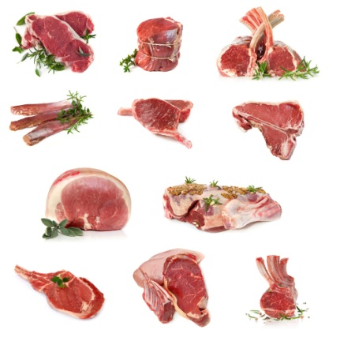
Potentially hazardous food is food that must be stored under special temperature conditions (out of the Temperature Danger Zone – see below) to prevent the growth of food poisoning bacteria or to prevent the formation of toxins in the food.
The list of potentially hazardous food (also known as ‘high risk’ food and/or ‘potentially dangerous’ food) is really without end but focuses on high protein, high moisture, low acid foods.
Potentially hazardous foods include:
- Milk and milk products, soft cheeses – butter, yoghurt, custards, cream cakes, cheese, baked custard tarts and dips
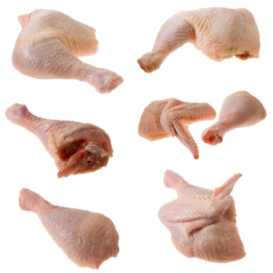
- Egg products – quiche, fresh pasta, duck and game bird eggs, all eggs, mayonnaise (whole egg)
- Meat and poultry – all types of meat (beef, lamb, pork, chicken, turkey) and all cuts (sides, loins, steaks, chops, ribs, mince)
- Smallgoods products – ham, pressed chicken, but note most salami is not a high risk food due to its high salt and low moisture content
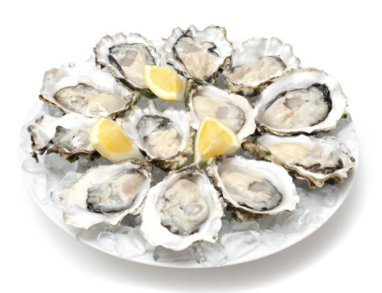
- Processed meat products including chicken – pate, meat pies, sausages, sausage rolls, coagulated blood, rissoles, meat balls
- Fish, shellfish, fish products, fish soups and fish stocks – caviar, fish balls, patties, salads, sauces and stews
- Other food dishes – pizza, prepared meals, sandwiches, salads and cooked rice and cooked pasta.

Temperature Danger Zone
The Temperature Danger Zone is the temperature range in which food poisoning bacteria multiply most rapidly.
The range is 5ºC to 60ºC.
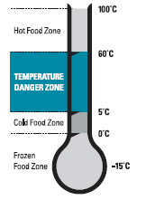
Every effort must be made to keep potentially hazardous food out of this temperature range.
Where food has to be in this range (such as when it is being prepared), the amount of time it spends in this zone must be minimised.
It is important to note all time food spends in the Temperature Danger Zone is cumulative.
If a piece of meat is left out on the bench for one hour, refrigerated and then brought back out into the kitchen, the time it then spends in the Temperature Danger Zone is added to the previous time – the clock (and the bacteria count) does not get reset to zero when the food was put in the fridge again.
Picture provided through Victorian government.

The 2/4 Rule
Awareness of the 2/4 rule is critical in applying safe food handling procedures.
The 2/4 rule states:
- Potentially hazardous foods which have been in the Temperature Danger Zone for four hours (or more) must be discarded/thrown out
- Potentially hazardous foods that have been in the Temperature Danger Zone for two hours can be refrigerated and then returned to the Temperature Danger Zone for another two hours, maximum
- When high risk food has been in the Temperature Danger Zone for two hours it must be cooked or eaten within the next two hours or thrown out.
There are no exceptions to this rule.

Two-step rule for cooling hot food
The two-step rule provides direction for the cooling of high risk hot food.
It states:
Step 1:
Cool hot food down from 60°C (or above) to 21°C within two hours of removing the food from the stove, oven or other cooking unit.
Step 2:
Once the food has reached 21°C it should be placed into a refrigerator/cool room, and then cooled to 5°C (or below) within a further four hours.
If the cooling of high risk food does not meet these criteria, the food must be thrown out.
Once food has reached 5°C it can safely be put in the freezer.

Thawing food
Frozen food must be thawed before use (also known as ‘defrosting) using one of three methods:
- In a refrigerator/cool room – large pieces of meat may take two to three days to defrost so planning ahead is vital: this is the preferred method of thawing as the food is always out of Temperature Danger Zone
- If pressed for time, use a microwave to defrost, moving pieces of food during the procedure – food should be immediately cooked once taken from the microwave after defrosting
- Run the item under cold water (less than 20°C) – only suitable for small portions/items. Not suitable for products which have been ‘breaded’ or ‘crumbed’.
All meats should be cooked immediately after thawing.
It is not acceptable to thaw items out by placing them in a bowl or sink of water.

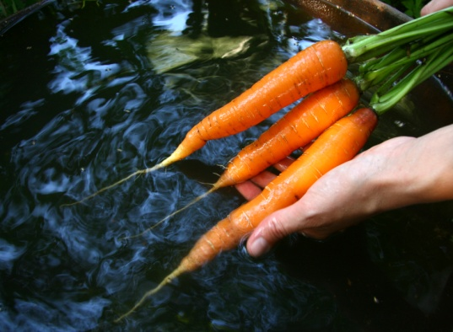
Clean
Clean means free from visible debris (dirt, food, grime) and free from objectionable odour.

Food processing
General requirements in relation to maintaining the safety of food while it is being processed or prepared include:
- Ensuring only safe and suitable food is processed – food unfit for consumption must not be processed.
This includes:
- Foods that look or smell ‘off’ or shows other signs of contamination
- Food that has exceeded its use-by date
- Protecting food being prepared from contamination – this includes preventing contamination from:
- Physical sources
- Chemicals
- Microbiological contamination – which may be caused by leaving potentially hazardous food in the Temperature Danger Zone for too long while it is being processed, or failing to cook food at the correct temperature. High risk food should reach an internal temperature of 75ºC which should be verified with a thermometer
- Ensuring all fruit and vegetables are washed in a sanitising solution before being prepared
- Excluding unhealthy people from food handling/processing activities – food processing activities including chopping, cooking, drying, fermenting, heating, pasteurising, thawing and washing, or a combination of these activities

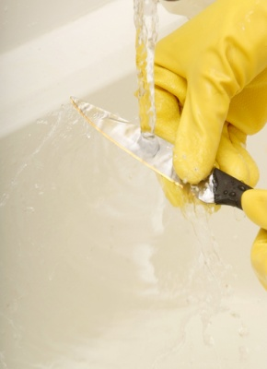
- Using clean equipment and utensils that have been sanitised and which are in proper working order – any piece of food equipment not working properly either raises safety and welfare risks for staff or presents the possibility the food processing job it was intended to do (such as to cook food to a certain temperature, or store or display food at a certain temperature) may not be achieved
- Ensuring chemicals are kept separated from food and food utensils and equipment during processing
- Keeping individual batches of processed food separate – batches of prepared food should never be mixed together as this can give rise to situations where food may remain able to be served even though it has passed its safe food date/time
- Avoiding touching cooked ready-to-eat food with the bare hands where it will not be subsequently cooked
- Discarding any food dropped on the floor
- Washing and sanitising any food handling tool, implement or utensil dropped on the floor before re-using it
- Avoiding coughing or sneezing over food or food preparation utensils, equipment or surfaces
- Using a tasting spoon to taste dishes.


Re-heating previously cooked food
It is quite legal to use or to reheat leftovers but there are several safe food hygiene practices to be followed in order to do it safely.
Leftovers, or food intentionally cooked beforehand and refrigerated or frozen for later use, are known as ‘previously cooked food’.
The following steps should be followed when reheating previously cooked food because many instances of food poisoning have been associated with incorrect reheating practices:
- Reheat in small quantities, not large – this reduces the time it spends in the Temperature Danger Zone (5°C – 60°C)
- Do not use a Bain-Marie for reheating, as they are only hot holding devices and not heating units
- Food must be protected from contamination while it is being re-heated
- The bain-marie must hold the heated food at a minimum 60°C so as to be above the Temperature Danger Zone (or The 2/4 Rule must be applied)
- It is preferable for food to be reheated immediately before service rather than to reheat in bulk and held for service
- Stir wet dishes held in the Bain-Marie regularly to make sure the food does not cool down to below 60°C – this applies even where the units have overhead heating lights
- Previously cooked food, coming from the cool room or a refrigerator, that is going to be reheated, must be raised to 70°C (for 2 minutes) as soon as possible and then kept at a minimum of 60°C – never leave previously cooked food sitting around in the kitchen on a preparation bench in the Temperature Danger Zone
- A temperature monitoring probe should be used to check the internal temperatures of food that is re-heated – never rely on guesswork, or the visual appearance of the food.

Food display
Display cabinets can be either hot or cold.
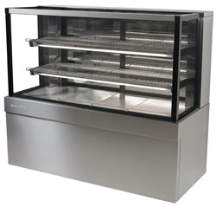
Cold food cabinets
When using cold food display cabinets:
- Food should be at or below 5°C
- Food should be covered/wrapped to prevent contamination
- Temperatures must be regularly checked (at least daily) using an independent thermometer
- Serve food using FIFO principles
- Protective guards must be provided (where appropriate) to prevent customers breathing, sneezing and/or coughing over the food
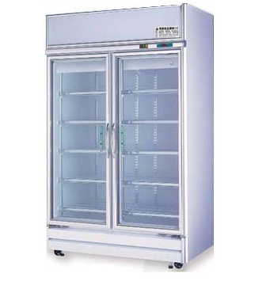
- Pre-prepared sandwiches and filled rolls should be stored in these cabinets – where they are not so stored, some system must apply (such as the use of colour-coded stick-on labels, or written times on the wrapping or container) that will allow control over the length of time the food spends in the Temperature Danger Zone
- Pre-prepared sandwiches and or filled rolls must not be sold or eaten when they have spent four hours or more in the Temperature Danger Zone.
Frozen food
Where the premises display frozen food, there is a requirement that the food remains hard frozen while on display.
Hot food cabinets
When using hot food cabinets:
- The temperature of the food must be over 60°C (or the 2/4 Rule must be applied)
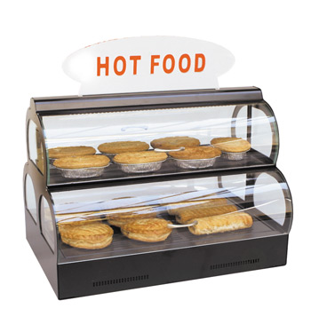
- Food to be put in hot food cabinets must be preheated rapidly before being placed in the cabinet
- Food should be served in the order it was placed in the cabinet to minimise risk of contamination (as well as guard against loss of taste, appearance and quality)
- Hot foods left from the day before should be served first, following the guidelines set out in ‘Re-heating previously cooked food’ – foods can only be re-heated once. Note some premises follow a standard operating procedure of discarding all left-over food
- Temperatures of food must be regularly checked (at least daily) using an independent thermometer
- Food must not be topped-up but rotated to keep it fresh and avoid mixing batches.

Self service food and unpackaged ready-to-eat food
When offering self-service food and unpackaged ready-to-eat food, you must ensure:
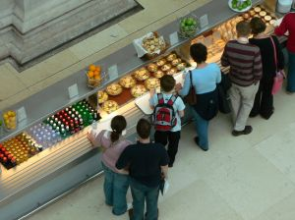
- Customer activities are routinely and regularly monitored so unsafe practices can be identified and remedial action taken – this means a staff member must be appointed to watch the customers in order to prevent them from doing anything to compromise the food, and/or to remove food from sale or service when it has been contaminated
- Special attention is paid to children at self-serve areas – they are prone to handling food with their hands, and taking food from displays and then putting it back
- Hot food is kept hot (60°C and above), and cold food is kept cold (5°C and below) or the 2/4 rule is applied
- Any utensils dropped by customers are immediately replaced with clean and sanitised ones
- Spills are cleaned up immediately
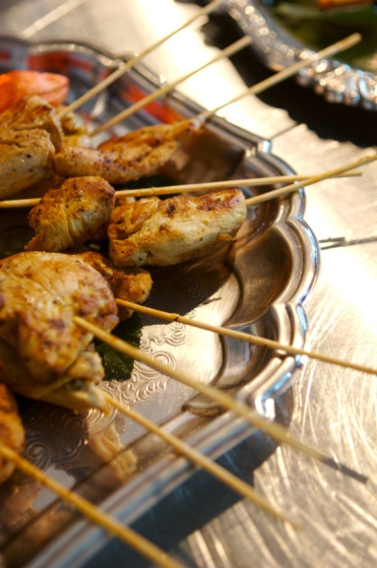
- Any contaminated food is thrown out – this includes contamination by customers coughing or sneezing over the food
- Signs are posted advising customers of safe food handling practices – such as asking them not to use utensils in other foods, to refrain from coughing and sneezing over the food, to refrain from handling any of the food with their bare hands
- Foods are covered and protected from contamination when not actually being used
- Separate utensils are provided for each and every food item
- Sneeze-guards are in place and are constructed/positioned to be effective
- Batches or trays of food items are not mixed – stock rotation is important but so is keeping batches separate
- Throw out any plate waste or returned food
- Small batches of food are put out – and replaced frequently, rather than putting out a large tray or platter to begin with
- Extra utensils are provided – there always seems to be a need for more
- Clean ‘rests’ for utensils (spoons and other service utensils) are provided and changed regularly to prevent cross-contamination
- The 2/4 rule is being complied with.

Food transportation
Premises may transport food as part of a home delivery service or as part of the outside catering services they offer.
Food transportation also covers the movement of food from kitchens to wards in hospitals and similar facilities.
Requirements in relation to the safe transportation of food are:
- A dedicated food delivery vehicle is used – food should not be transported in family cars
- The food storage area of the delivery vehicle is maintained in a clean condition been cleaned – also, any boxes, containers, transport boxes (including warmers) used to store food during transport must be clean
- Raw and cooked or ready-to-eat foods are kept physically separate – to avoid cross contamination
- The temperature of hot and cold food is checked prior to being loaded – hot food to be 60°C or above, and cold food to be 5°C or below: frozen food to be hard frozen
- Where hot food cannot be held at 60°C or above, it will need to be able to be delivered within two hours
- Where cold potentially hazardous food cannot be held at 5°C or below, it will definitely need to be able to be delivered within two hours
- Refrigerated food delivery vehicles must be able to hold food outside the Temperature Danger Zone – this may require the vehicle to be connected to mains power and pre-cooled prior to food being loaded into the vehicle
- Temperatures (and times) of food items are recorded onto a Food Delivery-Transportation log (or similar) when they are loaded into the food delivery vehicle
- Food is not loaded into the delivery vehicle until it is ready to be delivered
- All food is covered to protect it from contamination
- The delivery vehicle itself has been well maintained to minimise the risk of vehicle breakdown during food delivery
- Chemicals are not stored or transported with food items
- No pets or animals are allowed in the food delivery vehicle
- All doors on the food delivery vehicle should be locked when unattended.

Working behind the bar
Lots of staff work behind a bar and not in what is commonly regarded as a ‘food’ environment: it is important to remember beverages are a food.
The following actions are the basic food handling requirements for people who work behind a bar:
- Use a fork or tongs when putting fruit or ice in a glass – do not use fingers
- Do not re-use any fruit, straws, beverage, food, garnish left by a guest, or which comes back from the tables – it must be thrown out
- Ensure straws are correctly stored – they must be stored so they are kept free from flies, dust and contamination. They must be able to be obtained one at a time without the others being touched so it is not acceptable to store straws in a glass on the bar
- Check glass washing machine has detergent, and is operating at the prescribed temperature (which is 70° C)
- Put de-naturing agent in drip trays (drip trays are trays which are placed under beer drawing taps to catch the drips/overflow from glasses) – there must be sufficient de-naturing agent to actually de-nature the waste beer and stop premises pouring this waste beer back into the barrel
- No smoking or spitting behind the bar
- Wash hands at all times that kitchen-based food handlers are required to wash their hands
- Ensure clean clothes, hands and fingernails
- Stay away from work if ill or suffering from an infected cut: notify doctor of food handler status – bring a medical clearance stating fitness for work on return
- Ensure all glassware and utensils are clean – plates and glasses must also be free of chips and cracks.
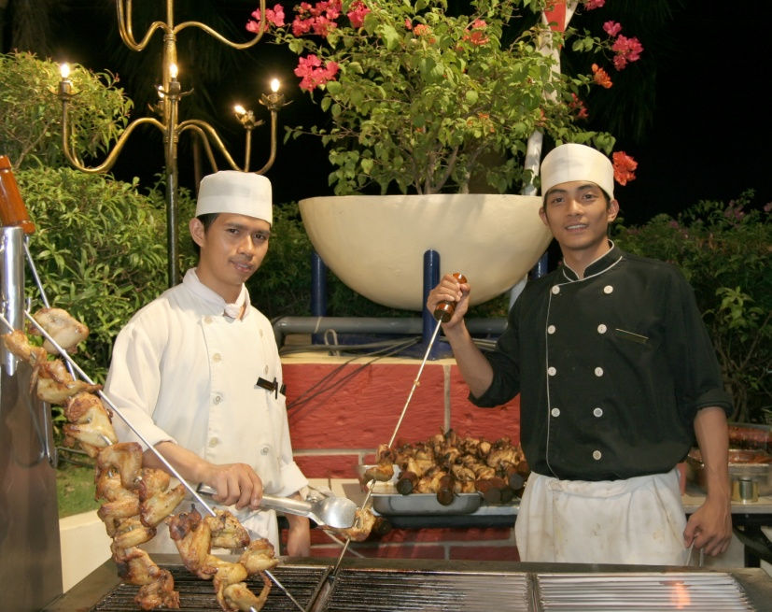

3.2 Handle and store foodstuffs in a manner that avoids damage and contamination, meets hygiene standards, and maintains quality

Introduction
In addition to previously stated food safety protocols there are other requirements which must be implemented when handling food.
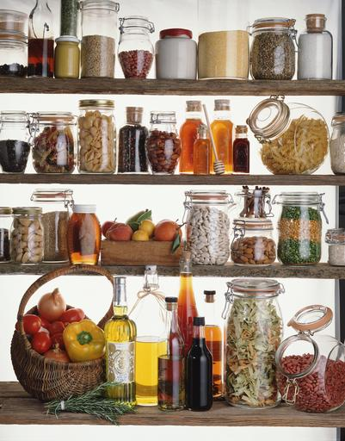
This section addresses stock rotation requirements and cleaning procedures.

Dry goods store
The dry goods store is a non-refrigerated store where canned and dried food is kept. It may be room-size, or a variety of cupboards and/or pantries.
Ensure
- The area is fly- and vermin-proof to minimise contamination by pests
- It is well ventilated and lit – to deter pests and to allow staff to see what they are doing and identify and remedy spillages
- It is never overstocked – excess stock costs money, clutters things up, and increases the chance of out-of-date stock being used
- It is fitted with doors which make a proper fit when fully closed to help exclude pests
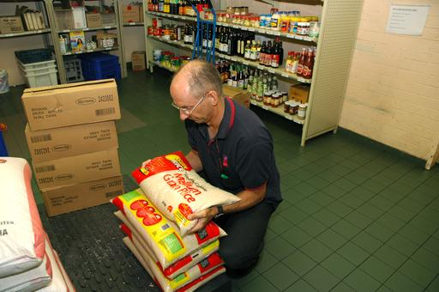
- The lowest shelf is sufficiently far enough above floor level to enable air circulation around produce, and to allow mops and brooms to reach under the shelves when cleaning is required
- Bulk food containers used are made from food grade materials and have tight-fitting lids – plastic garbage bins (even brand new/unused ones) are not permitted to be used for food storage as they are liable to splitting, do not have a smooth internal surface that facilitates cleaning and do not protect against mice and rats
- Food storage containers are cleaned and sanitised before being re-used/re-filled – to guard against batch-mixing
- Any canned, tinned or bottled food must be transferred to an appropriate container and refrigerated once the container has been opened – it is not acceptable (for example) to open a can, use half of the contents and then return the open can to dry storage. The food must be transferred to a plastic or stainless steel (or other appropriate) container and then placed in the refrigerator.

Refrigerated goods store
Refrigerated storage is used for fruit and vegetables, dairy products, meat and all other potentially hazardous foods.
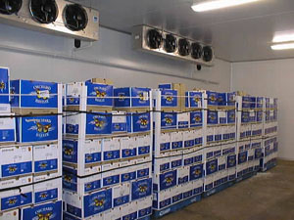
Refrigerated storage may occur in coolrooms, under-counter refrigeration units or domestic refrigerators.
Ensure:
- The temperature is kept at 5°C or below and this temperature is checked with an independent calibrated thermometer – checks must be done at least once per day
- The coolroom/refrigerator door is closed between uses and an effort made to minimise opening times by planning these openings – an open door raises the temperature and makes the unit more expensive to operate
- The cool room is not overcrowded to enable air to circulate freely around food items
- Food loads put into the coolroom/refrigerator are broken down into smaller units to enable faster cooling: where large units of food are placed in the refrigerator it takes a lot longer for the core of that food to move out of the Temperature Danger Zone.
Hot foods should be allowed to cool (perhaps by placing the food in pots into tubs full of a water-ice mixture) before being placed in the cool room: frequent stirring of the item will help it to cool quicker.
If ‘too much’ hot food is placed into refrigeration it will raise the temperature of the unit and may cause condensation which could lead to cross-contamination (see below).
The ‘Two-step rule for cooling hot foods’ must be complied with
- All food is covered and protected from contamination – plastic film with a label attached to identify the food and date it was placed under refrigeration may be used
- Potentially hazardous raw food is separated from cooked and/or ready-to-eat foods – this is to prevent cross contamination.

Frozen storage
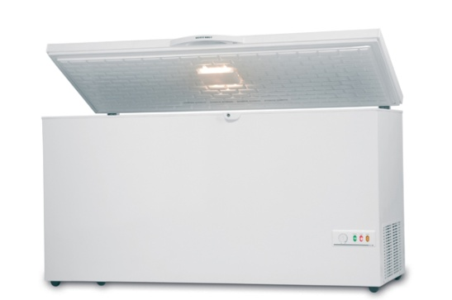
Freezers are used to store frozen produce.
Freezers may be chest type, up-right, or walk-in, but they must be maintained so the food remains hard frozen (recommended -15°C, although some properties require -18°C).
Every time the freezer is used, it should be standard practice to visually check the temperature gauge and notify management where there is a problem – do not overload freezers as it takes too long for the middle of products to freeze.
Ensure:
- Hot food is never frozen – cool it first following the two-step rule for cooling hot food
- Thawed items must never be refrozen
- That freezers are defrosted regularly to maintain operating effectiveness and encourage use (or disposal) of items
- Freezer doors are kept closed when the freezer is not in use
- Freezer temperature is be checked at least daily to ensure correct operating temperature
- Large pieces/amounts of food are not frozen as this encourages others to defrost the item and then re-freeze it – in practice this means:
- Freezing slices rather than slabs of meat
- Using shallow storage containers rather than deep ones
- Manufacturer’s instructions regarding the storage of frozen food products are followed – these may relate to storage temperatures and the length of time the product can be stored (for quality and/or safety reasons).

First In, First Out stock rotation
Effective stock rotation for foods means using the FIFO approach to stock rotation – First In, First Out.
This method requires food is used or served in the order it was delivered meaning the foods which have been in stock the longest are used first.
In practice this means when storing food:
- Old or existing stock must be moved forward on the shelf and the newly delivered stock must be placed behind it – this allows the stock at the front (the oldest stock) to be used before the newer stock
- Existing product in a chest freezer should be removed and the new stock placed at the bottom of the freezer – the existing/old stock is then replaced in the freezer on top of the newer stock.

Cleaning requirements
All businesses are required to keep their food premises and equipment clean which can be seen as a state in which there is no accumulation of:
- Garbage, except in garbage containers
- Recycled matter, except in containers
- Food waste
- Dirt
- Grease
- Other visible matter.
The business must also maintain all its fixtures, fittings and equipment (in a clean condition.
This requirement applies to things such as walls, floors, ceilings, windows, benches, shelves, sinks, wash hand basins, cupboards, grease filters, cooking equipment, food preparation equipment, food utensils, food vending machines, light fittings, ventilation ducts, pipes and electrical wiring.
Equipment used to do the cleaning (for example, brooms, mops and buckets, hoses) must also be cleaned – they should be cleaned, washed and/or sanitised after each use.
Cleaning tools and equipment
Cleaning tools and equipment used in a kitchen to clean equipment can include:
Clothes | Brushes | Sponges
Towels | Spray bottles | Grill cloths
Abrasive pads | Scrapers | Paper towel
Cleaning agents/chemicals
Cleaning agents/chemicals used to clean equipment in a kitchen may include:
Detergents | Sanitisers | Degreasers
Oven cleaners | Grill cleaners | Multi-purpose cleaners
Combi-oven cleaners | Glass cleaners | Cooktop cleaners
Dishwashing detergents | Rinse aids | Descalers

Cleaning procedures and techniques
Cleaning procedures and techniques for food preparation equipment can include:
- Allowing item to cool down before cleaning or disassembly (where required)
- Checking with other staff to determine item:
- Is no longer required and can be cleaned
- Needs to be cleaned
- Ensuring required cleaning tools, equipment and cleaning agents/chemicals are available
- Cleaning the item where it is physically located – or moving it to the cleaning area
- Making sure you know or have access to the required cleaning procedures and techniques for the individual item
- Pre-cleaning items – such as:
- Physically removing food scraps/debris
- Using bristle brush to remove food debris
- Rinsing
- Soaking in detergent solution
- Washing items:
- Thoroughly
- Using hot water
- Using designated appropriate detergent for the item and the cleaning job to be performed
- Scrubbing
- Using abrasive pads as required
- Rinsing items
- Sanitising the item – using hot water, steam or chemicals.

Sample cleaning instructions
Venues may have WIs or SOPs to assist with cleaning of equipment.
These documents can take a variety of forms but will provide advice/direction similar to the following:
Job | Description
Utensils and cutting boards – Daily | Clean utensils and cutting boards as required during trade & at the end of each day’s trade  Remove dry soil/debris and rinse with warm water  Wash with XYZ detergent, soaking as required rinse and sanitise  Rinse and allow to air dry.
Microwave – Daily | Clean the microwave as required during trade & at the end of each day’s trade  Wipe away loose debris and dirt with a clean cloth  Spot-clean and scrape identifiable problem areas  Wash with detergent and hot water, rinse and sanitise  Rinse and allow to air dry.
Multiple Ring Burners (including 2, 4, 6 & 8-ring burners) – Daily | Clean under the rings as required during trade and at the end of each day’s trade  Scrape identifiable problem/ areas with scraper  Wipe to remove debris  Wash with detergent and hot water, rinse and sanitise  Rinse and allow to air dry  Sanitise rings by steaming them in a Combi oven.
Robot Coupe Blender and all mixers (of all sizes, types & models) – Daily | Clean the blender and attachments as required during trade and at the end of each day’s trade  Dismantle as required, rinse with warm water first  Scrape identifiable problem areas with scraper (soaking where necessary)  Wipe to remove debris  Wash with detergent and hot water, rinse and sanitise  Rinse and allow to air dry.
Bain Marie – Daily | Clean the bain-marie at the end of each day’s trade  Remove bain-marie trays and wash them in sink using detergent and hot water, rinse and sanitise  Rinse and allow to air dry  Wash main unit (including any hot press and plate warmer cabinet) using detergent and hot water, rinse and sanitise: rinse and allow to air dry.
Salamander – Daily | Clean the salamander as required during trade and at the end of each day’s trade  Warm the salamander and spray with oven cleaner, leaving as per instructions  Wipe to remove debris  Scrape identifiable problem areas with scraper  Wash with detergent and hot water, rinse and sanitise  Rinse and allow to air dry.
Stock Pot – Daily | Clean the stock pot as required during trade and at the end of each day’s trade  Wipe away loose debris and dirt from pot with a clean cloth  Spot-clean and scrape identifiable problem areas  Wash inside and out with detergent and hot water, rinse and sanitise  Rinse and allow to air dry  Spot-clean and scrape base unit as required  Rinse, sanitise, rinse and allow to air dry.
Brat Pan – Daily | Clean the brat pan as required during trade and at the end of each day’s trade  Wipe away loose debris and dirt from pan with a clean cloth  Spot-clean and scrape identifiable problem areas  Wash inside and out with detergent and hot water, rinse and sanitise  Rinse and allow to air dry  Spot-clean and scrape base unit as required  Rinse, sanitise, rinse and allow to air dry.
Mincer – Daily | Clean the mincer as required during trade and at the end of each day’s trade  Dismantle as required, rinse with warm water first  Scrape identifiable problem areas with scraper (soaking where necessary)  Wipe to remove debris  Wash with detergent and hot water, rinse and sanitise  Rinse and allow to air dry.
Grater – Daily | Clean the grater as required during trade and at the end of each day’s trade  Dismantle as required removing grater blade, rinse with warm water first, soaking where necessary  Wipe hopper to remove debris  Wash with detergent and hot water, rinse and sanitise  Rinse and allow to air dry.
Toaster (including conveyor-type & wall-mounted type) – Daily | Clean the toaster as required during trade and at the end of each day’s trade  Heat the sandwich maker, if required  Wipe away loose debris and dirt with a clean cloth  Spot-clean and scrape identifiable problem areas  Wash with detergent and hot water, rinse and sanitise  Rinse and allow to air dry.

3.3 Store foodstuffs at the correct temperature

Introduction
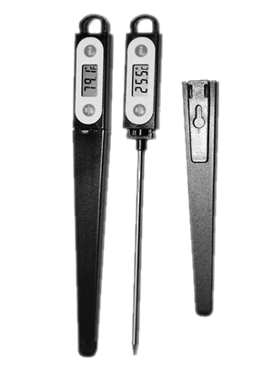
This section consolidates previously stated required temperatures for the storage and display of food.

Temperatures for storing food
Dry goods store
The dry goods store is a non-refrigerated store where canned and dried food are kept.
It may be room-size, or a variety of cupboards and/or pantries.
Desired temperature for dry store should be in the range 15°C to 20°C.
Refrigerated storage
Refrigerated storage is used for perishable fresh products such as fruit and vegetables, dairy products, eggs, meat, poultry and seafood.
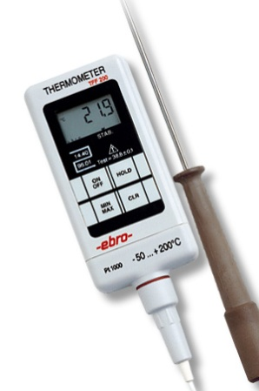
The basic requirement is storage is at 5°C or below.
Many operate at 2°C.
Meat poultry and seafood are best stored fresh at 1°C to 2°C.
If purchasing on daily basis this means a high turnover and 4°C is sufficient but if high risk foods are purchased less frequently then colder temperatures are best.
Fruit and vegetables require less severe temperature.
Tomatoes can be stored in the dry store if they are purchased regular basis.
Most vegetables only require refrigeration to keep their quality, not for food safety reasons.
Refrigerated storage may occur in coolrooms, under-counter refrigeration units or domestic refrigerators.
Frozen storage
Freezers are used to store frozen produce.
Freezers may be chest type, up-right, or walk-in, but they must be maintained such that the food remains hard frozen.
Standard operating range is -15°C to -18°C.

Display temperatures
Display temperatures for potentially hazardous food are:
- Cold food – at 5°C or below. Between 1°C and 5°C will keep high risk food out of the Temperature Danger Zone and prevent freezing of product (which makes it unattractive and unappealing to customers)
- Hot food – at 60°C or above
- Frozen food – maintained in a ‘hard frozen’ state (in the range of -15°C to -18°C or below).

Calibrated thermometer
All food premises must have an independent thermometer to check the temperature of food (on delivery, during processing, while on display), and check/monitor the temperature of food equipment (such as fridges, coolrooms, freezers, bain-maries, display units).
Most premises use a probe thermometer which can be inserted into food.
The use of infra-red thermometers is not recommended as they will only give surface temperature readings which are not accurate enough for food safety purposes.
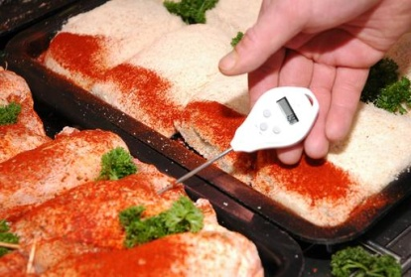
This thermometer must be:
- Readily available for food handling staff to use as required
- Checked and calibrated very six months (minimum) to ensure it is giving an accurate reading. Instructions on how to do a hot and cold calibration to check the accuracy of the thermometer are sometimes included in the instructions that accompany the thermometer when it is purchased
- Thermometers must be accurate to +/- 1ºC or they must be repaired or replaced
- Cleaned and sanitised between uses when it is being used to check the temperature of food – the use of a sanitising wipe to achieve this is common
- Allowed to reach room temperature when being alternated between use on hot and cold food or vice versa
- Treated with care – do not knock, drop or damage it: if it is knocked, dropped or damaged, it should be immediately checked for accuracy.

Calibrating the thermometer
As a fundamental rule – follow the manufacturer’s instructions for calibrating your workplace food thermometer. This said, the following generally applies to probe thermometers.
Cold Calibration
The following procedure must be applied at least every six months (you can do it more regularly) for the ice point calibration of thermometers:
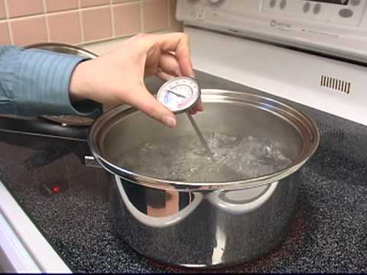
- Put ice and pre-cooled water (about half-and-half) into a container and allow to stand for about five minutes
- Insert the probe of the thermometer into the ice-water mixture and allow to stand for two minutes
- Record temperature reading – it should be 0°C – on Equipment Calibration Log, Independent Thermometer Calibration Record (or similar)
- Replace, repair or get recalibrated if temperature reading is ±1°C or more.
Hot Calibration
The procedure is:
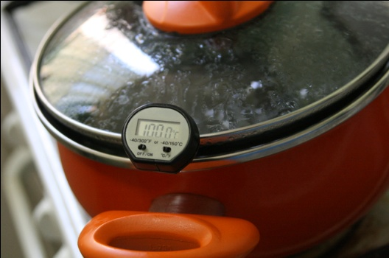
- Boil water and place thermometer probe into the boiling water
- Allow to stand for two minutes
- Record temperature reading – should be 100°C – on Equipment Calibration Log, Independent Thermometer Calibration Record (or similar)
- Replace, repair or get recalibrated if temperature reading is ±1°C or more.

Work Projects
It is a requirement of this Unit you complete Work Projects as advised by your Trainer. You must submit documentation, suitable evidence or other relevant proof of completion of the project to your Trainer by the agreed date.
3.1 Prepare a set of Standard Operating Procedures which could be used in a workplace by new food handlers to assist them in
- Handling food safely
- Storing and displaying foods correctly.
3.2. Prepare detailed cleaning instructions for one item of food preparation equipment identifying:
- Name of the item
- Frequency of cleaning
- Procedure to follow
- Cleaning chemicals and agents to be used
- Cleaning items and equipment to use.

Summary

Handle and store foodstuffs
When handling and storing food stuffs:
Inspect all food deliveries and reject unsafe or unsatisfactory food
Store food promptly under the correct conditions
Apply FIFO stock rotation
Keep stores neat and clean
Take special care with potentially hazardous foods
Keep time food spends in the Temperature Danger Zone to a minimum
Apply the 2/4 rule at all times
Follow the two-step rule for cooling hot food
Do not thaw food by leaving it on a bench or in a sink or bowl of water
Protect food and surfaces against contamination
Follow standard protocols for re-heating previously cooked food
Monitor all self-serve food situations
Remember beverages are classified as food
Check and maintain storage areas in good condition at required temperatures
Apply organisational requirements for cleaning food items and food areas
Use/wear PPE when handling chemicals
Calibrate food thermometers at least every six months.

Element 4:
Follow food safety program

4.1 Ensure work activities conform with the enterprise food safety program

Introduction
All food handling activities must comply with the requirements of any enterprise Food Safety Program.
Previous notes have addressed many of the requirements which will apply in relation to implementation of FSPs and this section describes the requirements for pest control and the handling and disposal of garbage.

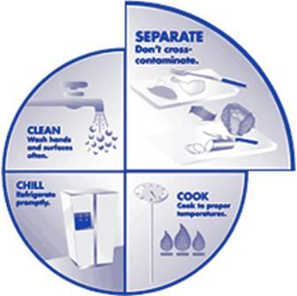
Importance of FSPs
Venues may be required by law to develop and implement a Food Safety Program/Plan or they may elect do so.
Regardless, a FSP will provide guidelines for safe food handling protocols in the business and compliance with the requirements of the plan is mandatory even where the plan itself is not a legislated requirement.
The FSP will have been developed after an analysis of the food handling operations of the business and will:
- Contain a range of detailed ‘support’ information on requirements (the safe food handling practices for the venue) for topics such as:
- Cleaning and sanitising – of equipment, utensils and work areas
- Personal hygiene practices and requirements
- Health of food handlers
- Equipment and property maintenance (for stores, kitchen, service areas)
- Thermometer use and calibration
- Pest control
- Waste disposal
- Identify the food safety records to be established and maintained by the venue
- Describe the training all food handlers must receive before they handle food.
A model FSP can be seen at http://www.health.vic.gov.au/foodsafety/bus/templates.htm.

Pest control
A successful program requires integration of three actions:
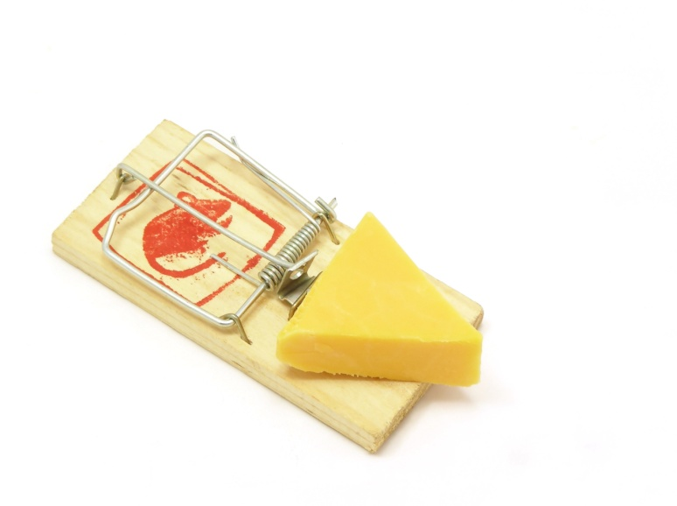
- Physical exclusion of pests – also known as ‘Build them out’
- Chemical and mechanical control – also known as ‘Chase them out’
- Sound housekeeping practices – also known as ‘Starve them out’.
Physical exclusion
Physical exclusion involves:
- Checking all deliveries to eliminate pests coming in with foodstuffs
- Correct fitting of fly wire to doors and windows
- Sealing of holes around pipes and other fittings that allow pests entry to the premises
- Exclusion of animals from food areas.
Chemical and mechanical control
Chemical and mechanical control includes the use of:
- Electronic fly and bug zappers
- Air curtains – above doors to food areas
- Traps – such as mouse and rat traps
- Bait stations – commercial products put in place by staff to poison pests
- Sprays – such as fly sprays
- Fogging – using commercial ‘bombs’
- Use of professional pest control companies.
Sound housekeeping practices
Good housekeeping involves:
- Ensuring equipment, floors, benches and other areas are properly cleaned and left dry at end-of-shift so no liquid or food remains to serve as a food source for pests and rodents.
- Inspecting under items of equipment at end-of-shift to make sure no food scraps are there
- Making sure no water remains after cleaning to serve as a drinking source for pests
- Removing cartons and other items which may provide shelter for them
- Correct storage of food in vermin-proof containers
- Making immediate repairs to cracked surfaces and tiles which can provide an inadvertent source of food.

Garbage
You should always:
- Wear disposable gloves when handling garbage
- Wash hands after handling garbage or bins.
Handling internal garbage
Requirements for the handling of garbage within the kitchen can include:
- Emptying internal bins regularly
- Emptying bins when three-quarters full – and not waiting until they are full and overflowing
- Always emptying internal bins at the end-of-shifts or service sessions
- Using bin liners
- Cleaning in and around bins – lift and move them so you can clean under them too
- Cleaning bins at the end of each shift nor session – using detergent and hot water.
Dealing with garbage outside the venue
Requirements for the handling of garbage outside the kitchen in external bins and dumpers include:
- Ensuring sufficient numbers of bins to cater for the waste produced by the business
- Making sure all bins have tight-fitting lids
- Keeping lids closed when bins are not in use – to help prevent access to garbage by pests
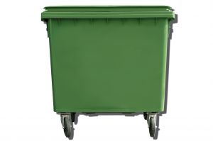
- Ensuring bins are in good condition – to prevent leaks and protect against access by vermin
- Cleaning the external bins and dumpers – using detergents, degreasers and deodorants
- Emptying external bins on a regular basis – to help avoid accumulation of rubbish and objectionable odours
- Applying appropriate recycling techniques.

4.2 Identify and monitor areas of risk in individual work area

Introduction
This section must be read in conjunction with section 1.1 and 1.2.

Context
An area of risk is frequently the result of poor organisational practices.
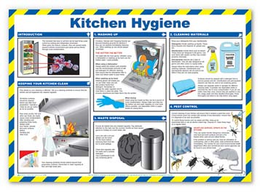
All food handlers are under an obligation to identify and report poor organisational practices that are inconsistent with required hygiene procedures.

This requirement applies whether the unsafe or poor practice relates to an organisational policy or procedure, or if it relates to the activities and practices of an individual food handler.
Poor organisational practice includes sub-standard performance by staff and compromises the requirements of your workplace FSP.

What are examples of poor organisational practices?
It is impossible to identify an all-inclusive list of possible bad/sub-standard practices but they are likely to fall into one of the following categories:
- Poor personal hygiene practices
- Poor food handling practices that may result in the contamination of food
- Poor cleaning practices that may result in cross contamination of food and other items including food preparation equipment, utensils and surfaces
- Practices that are inconsistent with the FSP for the premises
- Implementation and continuation of food handling practices that are out-dated by virtue of their failure to align with changing workplace conditions and food handling activities
- Use of equipment and utensils that are broken, damaged or otherwise failing to operate or function as intended
- Employment of staff who have not received the necessary and appropriate training to allow them to work effectively with the required skills and knowledge.
Remember the above list is only indicative and not presented as comprehensive - the potential for additional examples is significant.

Dangers and problems associated with poor organisational practices
Poor organisational food safety practices have the potential to cause a variety of issues for the premises, and for customers who eat their food.
Customers can be affected in the following ways:
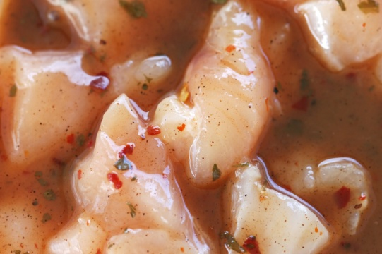
- Food poisoning – which can make them ill and even give rise to the need to take time off from work, seek medical attention or be hospitalised
- Death – every year a number of people die as a result of food poisoning.
The three sectors of society who are most susceptible to food poisoning (and subsequent death) are:
- The very young – babies and children
- The very old
- People who are already ill and or who have their immune system already compromised.
Businesses can be impacted by failure to implement required food safety practices in the following ways:
- They may be fined by the authorities
- The authorities may temporarily close the business down
- Jail for the owner or staff – especially in situations where there unsafe practices have been intentional (and designed to harm customers) or extremely negligent
- Being sued by customers
- Bad media exposure
- Permanent closure of the business
- Loss of jobs for staff – as a result of reduced trade, there is often less of a need for the business to employ as many staff.

Identifying and monitoring poor organisational practices
The key in identifying food safety issues within a business is awareness that everyday practices must be actively monitored and instances where control parameters (such as time, temperature, sources of supply, health of food handlers) are ‘out of control’ must be reported immediately.
Ways to identify ‘out of control’ situations in a food premises include:
- Encouraging and training staff to constantly be on the lookout for poor practices – constant attentiveness to food safety is critical
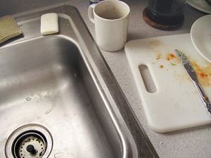
- Conducting regular workplace inspections using comprehensive checklists designed specifically for each individual premises – staff and management should cooperate in the conduct of these inspections and all areas listed on the checklists must be covered
- Raising staff awareness and maintaining that awareness in the workplace – through management initiatives such as:
- Refresher training for food handlers
- Recognitions and rewards for consistent safe food handling practices
- Development of posters to be put up throughout the food handling workplace
- Making food safety a standing item at all staff meetings/briefings
- Creating a workplace-based library of food safety information, references and fact sheets
- Undertaking personal observation – of all food handling areas and practices
- Conducting formal audits of the workplace every six months to identify areas and issues that may require attention.

4.3 Take corrective actions within individual scope of responsibilities to minimise risk in accordance with the enterprise food safety program

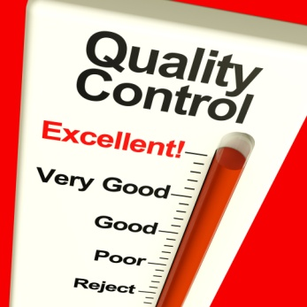
Introduction
The corrective action needed in response to a food safety risk or hazard will depend on what has been identified.
This section presents a range of possible actions across a range of situations in various food handling situations.

CAR
Corrective action is action taken to address or retrieve an out-of-control situation.
When corrective action is taken in response to a food safety issue there is usually a need to complete an establishment-specific Correct Action Report.
This will detail:
- Date and time of the event
- Indicator which identified there was a problem – for example ‘Temperature reading of cool room was 15˚C at 5:30AM when I arrived for work’, or ‘Mice droppings found in food’
- Food involved – naming and describing the type and amount of food
- Action taken to address the problem – explaining (for example):
- ‘Discarded food’
- ‘Called service technician to check and repair cool room’.
Recording corrective action taken should not be regarded as an ‘admission of guilt’ in relation to an out-of-control situation – rather, it should be seen as a positive indication you were actively monitoring food safety and took appropriate action when the need to do so arose.

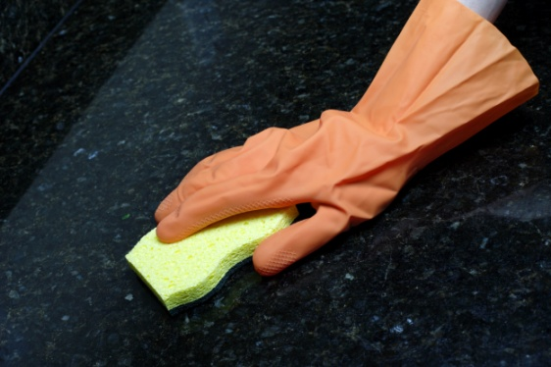
Scope of responsibility
Your individual scope of responsibility refers to the authority you have to take action without needing to have it approved by someone else.
If action is required which falls outside your personal scope of responsibility you must report/refer the matter to the ‘appropriate person’ (see next section).

Possible corrective action in relation to the purchasing of food
Depending on the out of control situation identified, Corrective Action may include:
- Obtain proof from suppliers they are registered as a food business and or have a FSP in place and operational
- Add required/new suppliers to Approved Suppliers List (see next section) as necessary
- Set purchase specifications for suppliers to comply with.

Possible corrective action in relation to receiving food
Depending on the out of control situation identified, Corrective Action may include:
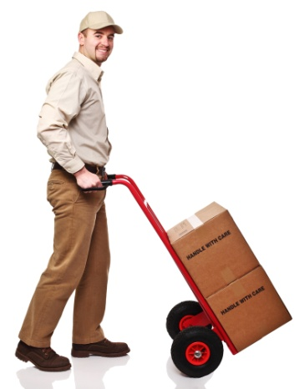
- Refuse/reject refrigerated high risk foods delivered at more than 5°C (or as otherwise stated in your FSP)
- Refuse and reject frozen produce not hard frozen
- Refuse and reject hot food delivered at less than 60°C – unless you are convinced it has been at this temperature for less than two hours: note this food must be thrown out after it has spent four hours total (including delivery time) in this temperature range
- Refuse and reject products which are not adequately marked with manufacturer’s details
- Refuse and reject food delivered in an unclean vehicle, or which is being delivered in a non-food vehicle such as a private car
- Refuse and reject foods delivered to you mixed in with chemicals: this includes refusing and rejecting foods where the chemicals were sealed and unopened – food and chemicals must not be mixed together even in their original containers.

Possible corrective action in relation to the storage of dry food
Depending on the out of control situation identified, Corrective Action may include:
- Where there is evidence of pest or rodent infestation:
- Lay baits
- Engage the services of a licensed pest control company
- Investigate where they are getting in and make repairs – fit fly wire, fill in holes
- Record the action you take on the Corrective Action form
- Throw away all infested and contaminated food
- Update and or repair lighting, globes, fluorescent tubes
- Revamp stock control measures – throw away out-of-date food
- Allocate more space for dry storage of food where conditions are too crowded or cramped
- Train staff in stock control procedures
- Discard products with damaged packaging
- Revise cleaning protocols – allocate more time, get more or better equipment and or chemicals, provide training in cleaning, clean the area more frequently.

Possible corrective action in relation to storage of refrigerated food
Depending on the out of control situation identified, Corrective Action may include:
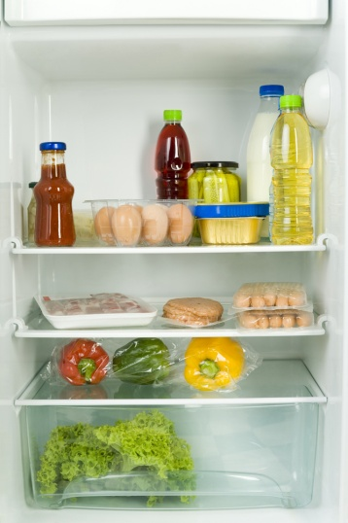
- Discard all food that exceeds the ‘2/4 rule’
- Discard all food beyond its ‘use by’ date
- Train staff in cleaning techniques and practices
- Call in refrigeration mechanic where the refrigeration units are reading above 5°C: consider implementing a preventative maintenance schedule through a reputable refrigeration company
- Discard all food where there is evidence – or a belief – cross contamination has occurred
- Revamp stock control procedures, as required
- Revamp cleaning procedures, as necessary.

Possible corrective action in relation to storage of frozen food
Depending on the out of control situation identified, Corrective Action may include:
- Where frozen food has thawed out but is still below 5°C, you are allowed to refrigerate it and then treat it as refrigerated food
- Where frozen food has been allowed to reach 5°C or higher (perhaps the freezer has broken down or there has been an extended power failure) for less than four hours – you may use it if you do so immediately
- If the frozen food has been at 5°C or more for more than four hours – throw it out
- If the frozen food has been at 5°C or more for an indefinite amount of time – that is, you are not certain how long it has been at 5°C or above – discard it all
- Discard all food that exceeds the ‘2/4 rule’
- Discard all food that is beyond its ‘use by’ date
- Train staff in cleaning techniques and practices
- Call in refrigeration mechanic where the freezer units are reading above -15°C: again, consider implementing a preventative maintenance schedule through a reputable refrigeration company
- Discard all food where there is evidence – or a belief – cross contamination has occurred
- Revamp stock control procedures, as required
- Revamp cleaning procedures, as necessary.

Possible corrective action in relation to thawing frozen food
Depending on the out of control situation identified, Corrective Action may include:
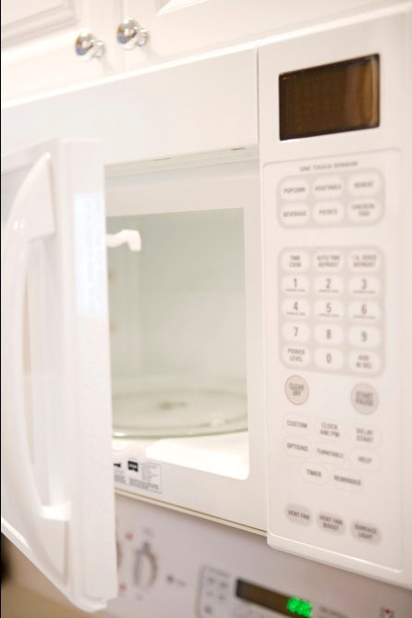
- Train staff to wait until food is fully thawed before cooking
- Train staff in proper thawing practices, including the need to plan defrosting needs
- Discard all food that exceeds the ‘2/4 rule’
- Throw out all food defrosted in an uncovered state, or which has defrosted in damaged packaging
- Discard all food that has been thawed and re-frozen
- Train staff not to re-freeze thawed product.

Possible corrective action in relation to the preparation of food
Depending on the out of control situation identified, Corrective Action may include:
- Supply sufficient time and resources to facilitate compliance with correct food handling practices – this may be gloves, extra utensils (knives, chopping boards, bowls), more time for hand washing
- Put up signs to remind staff of correct and safe food handling practices
- Revamp preparation procedures and practices so as to minimise time food spends in the Temperature Danger Zone – this may include spending time planning food preparation activities on a daily basis
- Improve stock rotation procedures – if out-of-date items are being identified during this phase
- Apply the ‘2/4 rule’
- Change cloths and swabs regularly – at least hourly: consider using paper towels instead
- Monitor the performance of individual staff members in relation to food preparation-food safety issues, and suggest improvements to practice where this is deemed necessary
- Train staff as required.

Possible corrective action in relation to cooking of food
Depending on the out of control situation identified, Corrective Action may include:
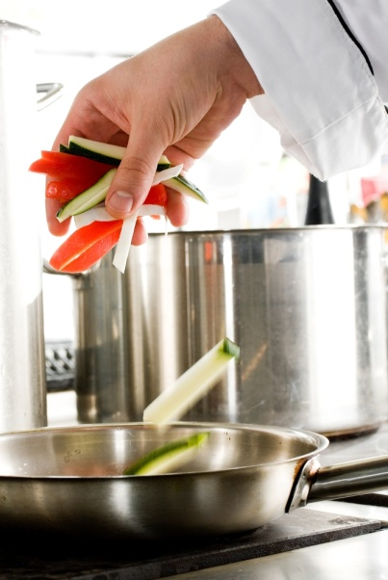
- Repair equipment where cooking equipment is functioning below required standards
- Cook food in smaller batches
- Provide special purpose tasting spoons
- Verify thermometer readings – via calibration at least every six months
- Train staff as required
- Provide – and/or use – covers for food as it is cooked.

Possible corrective action in relation to the cooling of hot food
Depending on the out of control situation identified, Corrective Action may include:
- Help hot foods to cool down by placing hot pots/containers into iced water baths
- Stir wet dishes to help release heat
- Cover cooling dishes
- Set clocks, watches or alarms to notify of required timeframes
- Make sure new staff at any change of shift are notified in relation to any food that is cooling
- Verify thermometer readings – via calibration every six months (minimum)
- Train staff as required
- Place signs around the workplace to remind staff of what is required in relation to the cooling of food.

Possible corrective action in relation to storing and holding of hot food
Depending on the out of control situation identified, Corrective Action may include:
- Train staff as required – handling, heating, display, stock rotation and cleaning protocols
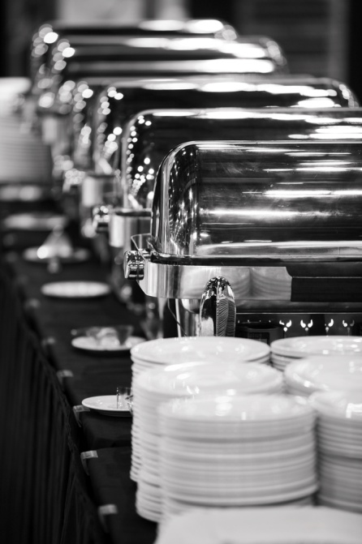
- Revamp hot holding procedures to ensure food stays at or above 60°C
- Check operational efficiency and accuracy of all hot holding equipment and have units serviced as required
- Pre-heat all food properly (minimum 70°C for two minutes) prior to placing it into pre-heated holding devices
- Ensure temperatures of all hot held food are being taken as required using a properly calibrated thermometer
- Revise display protocols if tags are actually touching food
- Revamp times when bain maries and warmers are turned on – turn them on earlier to allow sufficient time for them to get to 60°C or above
- Operate bain maries and/or warmers at higher settings so as to reach 60°C.

Possible corrective action in relation to the storing and holding of cold food
Depending on the out of control situation identified, Corrective Action may include:
- Train staff as required – handling, cooling, display, stock rotation and cleaning protocols
- Revamp cold holding procedures to ensure food stays at or below 5°C
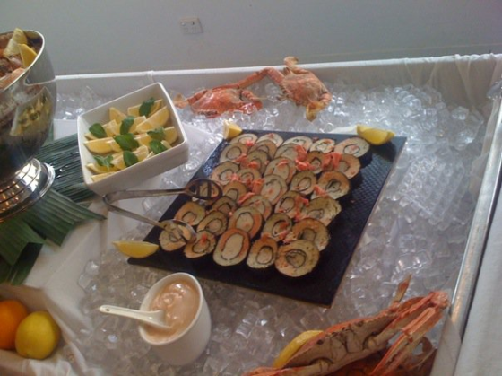
- Check operational efficiency and accuracy of all cold holding equipment and have units services as required
- Ensure all food that goes into cold display units is already at or below 5°C
- Ensure temperatures of all cold held food are being taken as required using a properly calibrated thermometer
- Revise display protocols if tags are actually touching food
- Revamp times when cold display units are turned on – turn them on earlier to allow sufficient time for them to get to 5°C or below
- Operate units at lower settings so as to reach 5°C or less.

Possible corrective action in relation to the re-heating of food
Depending on the out of control situation identified, Corrective Action may include:
- Revamp re-heating procedures to ensure 70°C for two minutes or higher is attained, and display/holding protocols ensure 60°C or higher is maintained
- Alter re-heating practices to re-heat quicker and/or in smaller quantities
- Throw out re-heated food that fails to reach a core temperature of 70°C or higher for at least two minutes
- Train staff – as required.

Possible corrective action in relation to packaging of food:
Depending on the out of control situation identified, Corrective Action may include:
- Dirty and damaged containers and other packaging materials are discarded
- Service packaging equipment correctly and regularly
- Ensure packaging area is kept pest free – consider using a pest control company
- Verify the cleaning schedule for the packaging area is operating as intended – amend as required
- Train staff – as required
- Modify labelling so it conforms with requirements
- Discard all food contaminated during the packaging/re-packaging process.

Possible corrective action in relation to the service of food
Depending on the out of control situation identified, Corrective Action may include:
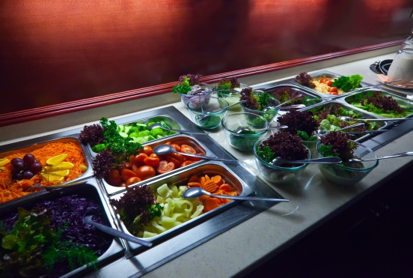
- Discard all food exceeding the ‘2/4 rule’
- Train staff in correct food handling and serving practices
- Purchase sufficient equipment and utensils to enable separate utensils for each food item
- Maintain food holding equipment so the required holding temperatures for hot and cold food can be obtained
- Alter the settings on units so the required display/holding temperatures can be achieved.

Possible corrective action in relation to the self-service of food by customers
Depending on the out of control situation identified, Corrective Action may include:
- Prepare public food handling signage
- Consider alternative serving options if the safety/integrity of food cannot be guaranteed
- Allocate additional staff to observe customer food handling practices
- Discard all food that exceeds the ‘2/4 rule’
- Train staff in correct monitoring procedures – and in appropriate customer relations skills to facilitate compliance with requirements
- Purchase sufficient equipment and utensils to enable separate utensils for each food item
- Maintain food holding equipment so the required holding temperatures for hot and cold food can be obtained
- Alter the settings on units so the required display/holding temperatures can be achieved.

Possible corrective action in relation to the transportation of food
Depending on the out of control situation identified, Corrective Action may include:
- Obtain and use specially designated ‘Food Transport Vehicles’
- Service Food Transport Vehicles regularly
- Ensure food can be delivered within 2 hours
- Throw out all food exceeding the ‘2/4 rule’
- Discard any contaminated food items
- Train staff as necessary.

4.4 Report risks beyond the control of the individual to the appropriate person(s)

Introduction
Staff who identify a food hygiene hazard are expected to take immediate action within their scope of authority to resolve the issue.
However, not all hygiene hazards can be effectively addressed by staff because they may require action that extends beyond their designated scope of authority.
Where these situations occur, the hazards must be reported so that the appropriate person can take the necessary action.
This section addresses this requirement.

Who is the ‘appropriate person’?
The appropriate person will depend on the structure and size of the business, but can be expected to be one or more of the following:
- The Food Safety Supervisor

- A department or shift supervisor
- The department or venue manager
- The owner
- Any member of the establishment food safety team/committee (where one exists)
- Head office – this may be an option where the business is a large one that has numerous food outlets/sites and where the organisation operates its own laboratory that is central to establishing and maintaining food safety throughout all food sites.

How should these reports be made?
Immediate verbal reports must be made as soon as the hazard has been identified and these can/may need to be followed up with written reports.
The acceptable ways are:
- Verbally – face-to-face
- Via the telephone
- Using e-mail
- Completing nominated food safety reports forms.

Considerations when making a report
When making a report (verbal or written) attention should be paid to:

- Stating the facts as believed to be – for example, based on actual personal experience or personal observation: there is no room for bias, conjecture or making up things
- Being comprehensive – giving all the information
- Being specific – if possible, give dates, times, temperatures, supplier names, names of products, names of menu items, staff names
- Being immediate – where food safety is concerned there is always a need for reports to be made immediately/as soon as possible.

4.5 Complete records according to enterprise requirements and work responsibility

Introduction
Your FSP will indicate the records which need to be completed to support food safety activities in the business.
This section identifies a range of common documents.

Examples of food safety records
The records to be kept will reflect the identified potential hazards for each business and the food handling processes to be used within the business (as determined by an analysis of the food handling operations of the business).
Every FSP requires an assortment of documents to be kept which will help record the actual operation of the business from a food safety point of view.
These documents/records can include:
- Approved Food Suppliers List – listing those businesses from whom the food may be bought
- Goods Receiving Form – recording a proportion (say, 5%) of inwards food deliveries to the property
- Goods Rejected Form – detailing which have been delivered to the venue but refused/rejected
- Cold Storage Temperature Log – recording the daily temperatures of fridges, freezers and cool rooms
- Ready To Eat Food On Display Log – recording the daily temperatures of both hot and cold foods which are on display
- Hot Display Temperature Log – recording the daily temperatures of hot foods on display in units such as bain-maries and warmers

- Cold Display Temperature Log – recording the daily temperatures of cold foods in units such as salad wells or refrigerated display cabinets
- Equipment Calibration Log – detailing testing of probe thermometers to prove they are providing accurate readings, or to show they need repair or replacement
- Internal Review – Process Temperature Log – detailing on some regular basis (such as once every two weeks) the processing of a food item by tracking and recording the processes used (such as thawing, preparing, cooking, cooling, re-heating, displaying, serving) and recording the times and temperatures involved at each process step
- Corrective Action form – detailing action taken in response to an out-of-control situation.
Examples of food safety records can be found at http://www.health.vic.gov.au/foodsafety/downloads/fspt_class2_records.pdf.

Work Projects
It is a requirement of this Unit you complete Work Projects as advised by your Trainer. You must submit documentation, suitable evidence or other relevant proof of completion of the project to your Trainer by the agreed date.
4.1 Identify one out-of-control food safety situation and prepare a submission which:
- Describes the out-of-control situation
- Explains how you might identify the situation (what are the warning signs or indicators that there is a problem?)
- Presents standard work practices which could have prevented the out-of-control situation occurring
- Describes the standard monitoring activities which apply to the issue or work situation
- Explains the corrective action which could be taken to effectively address the situation
- Provides a brief written report addressing identification and response to the situation
- Names the records or documents relevant to the situation.

Summary

Follow food safety program
When following food safety program:
Obtain, read and understand the venue-specific FSP
Identify personal responsibilities under the plan
Implement required pest control procedures
Handle waste in accordance with requirements
Be alert to potential for poor organisational practices
Implement strategies to identify non-compliance with FSP requirements and poor organisational practices
Realise the impact of non-compliance on people and the business
Determine personal scope of responsibility for food safety action
Take suitable corrective action to effectively address identified out-of-control situations
Refer or report issues you cannot remedy
Complete food safety records as and when required.

Presentation of written work

1. Introduction
It is important for students to present carefully prepared written work. Written presentation in industry must be professional in appearance and accurate in content. If students develop good writing skills whilst studying, they are able to easily transfer those skills to the workplace.

2. Style

Students should write in a style that is simple and concise. Short sentences and paragraphs are easier to read and understand. It helps to write a plan and at least one draft of the written work so that the final product will be well organised. The points presented will then follow a logical sequence and be relevant. Students should frequently refer to the question asked, to keep ‘on track’. Teachers recognise and are critical of work that does not answer the question, or is ‘padded’ with irrelevant material. In summary, remember to:
- Plan ahead
- Be clear and concise
- Answer the question
- Proofread the final draft.

3. Presenting Written Work
Types of written work
Students may be asked to write:
- Short and long reports
- Essays
- Records of interviews
- Questionnaires
- Business letters
- Resumes.
Format
All written work should be presented on A4 paper, single-sided with a left-hand margin. If work is word-processed, one-and-a-half or double spacing should be used. Handwritten work must be legible and should also be well spaced to allow for ease of reading. New paragraphs should not be indented but should be separated by a space. Pages must be numbered. If headings are also to be numbered, students should use a logical and sequential system of numbering.
Cover Sheet
All written work should be submitted with a cover sheet stapled to the front that contains:
- The student’s name and student number
- The name of the class/unit
- The due date of the work
- The title of the work
- The teacher’s name
- A signed declaration that the work does not involve plagiarism.
Keeping a Copy
Students must keep a copy of the written work in case it is lost. This rarely happens but it can be disastrous if a copy has not been kept.
Inclusive language
This means language that includes every section of the population. For instance, if a student were to write ‘A nurse is responsible for the patients in her care at all times’ it would be implying that all nurses are female and would be excluding male nurses.
Examples of appropriate language are shown on the right:
Mankind | Humankind
Barman/maid | Bar attendant
Host/hostess | Host
Waiter/waitress | Waiter or waiting staff

Recommended reading
Australia New Zealand Food Authority; 2001 (2nd edition); Safe food Australia: a guide to the food safety standards; Australia New Zealand Food Authority
Ballard, Carol; 2010; Food safety; Gareth Stevens Publishing
Bitmead, Genevieve & Brown, Marion & Chisholm Institute of TAFE; 2010 (6th edition); Safe food handling; Chisholm Institute of TAFE
CSIRO, Food and Nutritional Sciences; 2010; Make it safe: a guide to food safety; CSIRO Publishing
Food Standards Australia New Zealand; 2002; Food safety: skills and knowledge for food businesses; guidance for food businesses on the skills and knowledge requirement of Food Safety Standard 3.2.2, Food Safety Practices and General Requirements; Food Standards Australia New Zealand, Canberra, A.C.T
Food Standards Australia New Zealand; 2002, Food safety: temperature control of potentially hazardous foods; Food Standards Australia New Zealand
Health Training Australia (Firm); 2000; HLTFS207B Follow basic food safety practices: learning guide; Health Training Australia
Hickman, Alan & Walters-Quan, Suzanne; 2006; WRRLP6C Apply retail food safety practices; Pearson Education Australia
Knechtges, Paul L; 2012; Food safety: theory and practice; Jones & Bartlett Learning
McSwane.D, Linton.R, Rue.N; 2004 (4th edition); Essentials of Food Safety and Sanitation; Prentice Hall
National Restaurant Association; (2006, 6th edition); ServSafe Manager; Prentice Hall
Pulle, Mervyn 2003, Food hazards: factors that affect food safety, Knowledge Books and Software, Sandgate, QLD
Rue.N,Williams.A; 2002; Quick Reference to Food Safety and Sanitation; Prentice Hall
SmallPrint Australia (Firm) 2008, Tourism, hospitality and events training. SITXOHS002A, Follow workplace hygiene procedures: assessor/trainer guide, Version VC6, smallPRINT, [Australia]

Trainee evaluation sheet

Apply standard safety procedures for handling foodstuffs
The following statements are about the competency you have just completed.
Please tick the appropriate box | Agree | Don’t Know | Do Not Agree | Does Not Apply
There was too much in this competency to cover without rushing.
Most of the competency seemed relevant to me.
The competency was at the right level for me.
I got enough help from my trainer.
The amount of activities was sufficient.
The competency allowed me to use my own initiative.
My training was well-organised.
My trainer had time to answer my questions.
I understood how I was going to be assessed.
I was given enough time to practice.
My trainer feedback was useful.
Enough equipment was available and it worked well.
The activities were too hard for me.

The best things about this unit were:

The worst things about this unit were:

The things you should change in this unit are:

Trainee Self-Assessment Checklist
As an indicator to your Trainer/Assessor of your readiness for assessment in this unit please complete the following and hand to your Trainer/Assessor.

Apply standard safety procedures for handling foodstuffs
 |  | Yes | No*
Element 1: Identify hazards and risks
1.1 | Identify key hazards and risks associated with the individual work role
1.2 | Check own work area to identify hazards and risks
Element 2: Follow enterprise hygiene standards, procedures and practices
2.1 | Implement required personal hygiene practices
2.2 | Maintain clothing to meet work area standards
2.3 | Follow hygiene procedures in accordance with enterprise requirements
Element 3: Handle and store foodstuffs
3.1 | Handle and store foodstuffs according to enterprise guidelines
3.2 | Handle and store foodstuffs in a manner that avoids damage and contamination, meets hygiene standards, and maintains quality
3.3 | Store foodstuffs at the correct temperature
Element 4: Follow food safety program
4.1 | Ensure work activities conform with the enterprise food safety program
4.2 | Identify and monitor areas of risk in individual work area
4.3 | Take corrective actions within individual scope of responsibilities to minimise risk in accordance with the enterprise food safety program
4.4 | Report risks beyond the control of the individual to the appropriate person(s)
4.5 | Complete records according to enterprise requirements and work responsibility

Statement by Trainee:
I believe I am ready to be assessed on the following as indicated above:
Signed: | _____________________________ | Date: | ______ / ______ / ______
Note:
For all boxes where a No* is ticked, please provide details of the extra steps or work you need to do to become ready for assessment.





